**CSS Box Model**

All HTML elements can be considered as boxes an consists of:

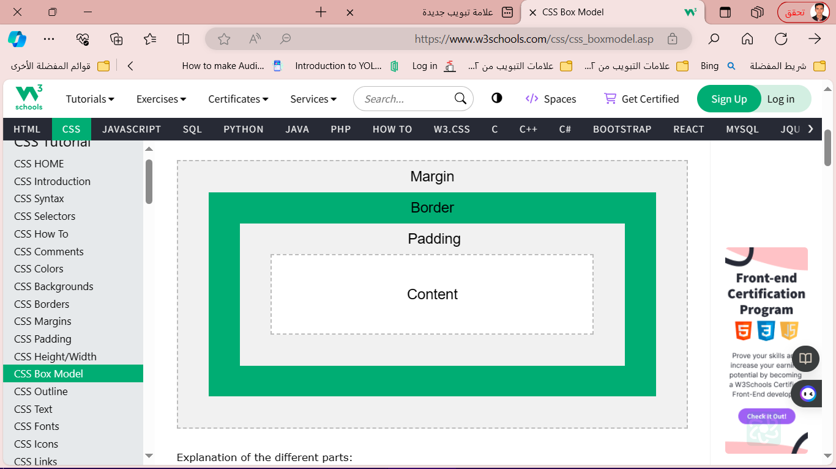

* **CSS Text**

CSS has a lot of properties for formatting text.

* **Text Color**
* text-align
* text-align-last
* direction
* unicode-bidi
* vertical-align
* **CSS Text Alignment and Text Direction**

1. **Text Alignment**

is used to set the horizontal alignment of a text.text can be left or right aligned, centered, or justifie

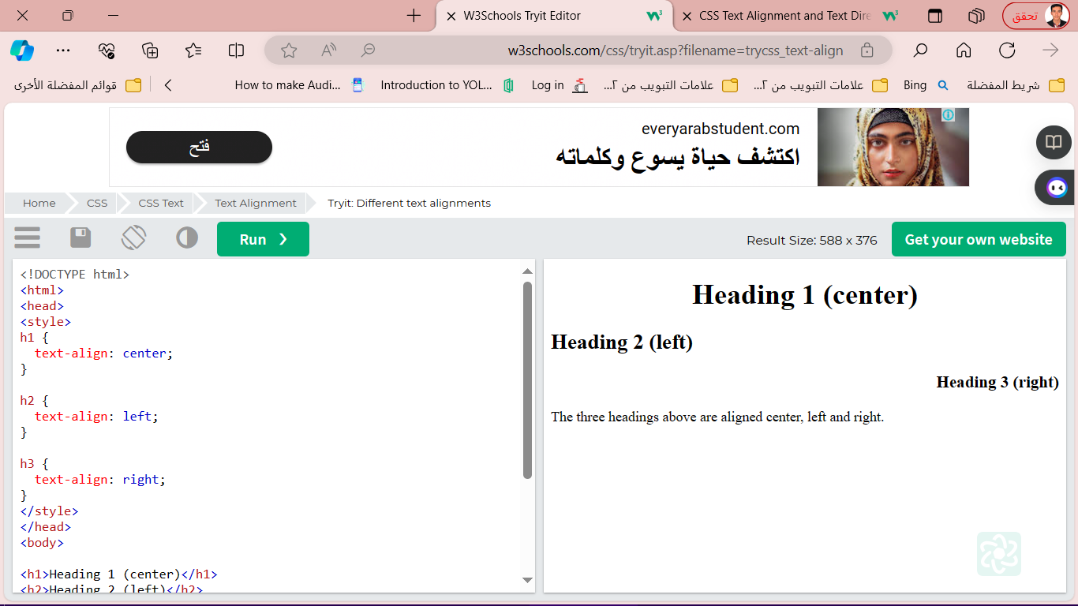Example

h1 {  
  text-align: center;  
}  
  
h2 {  
  text-align: left;  
}  
  
h3 {  
  text-align: right;  
}

1. **Text Align Last:** The text-align-last property specifies how to align the last line of a textز

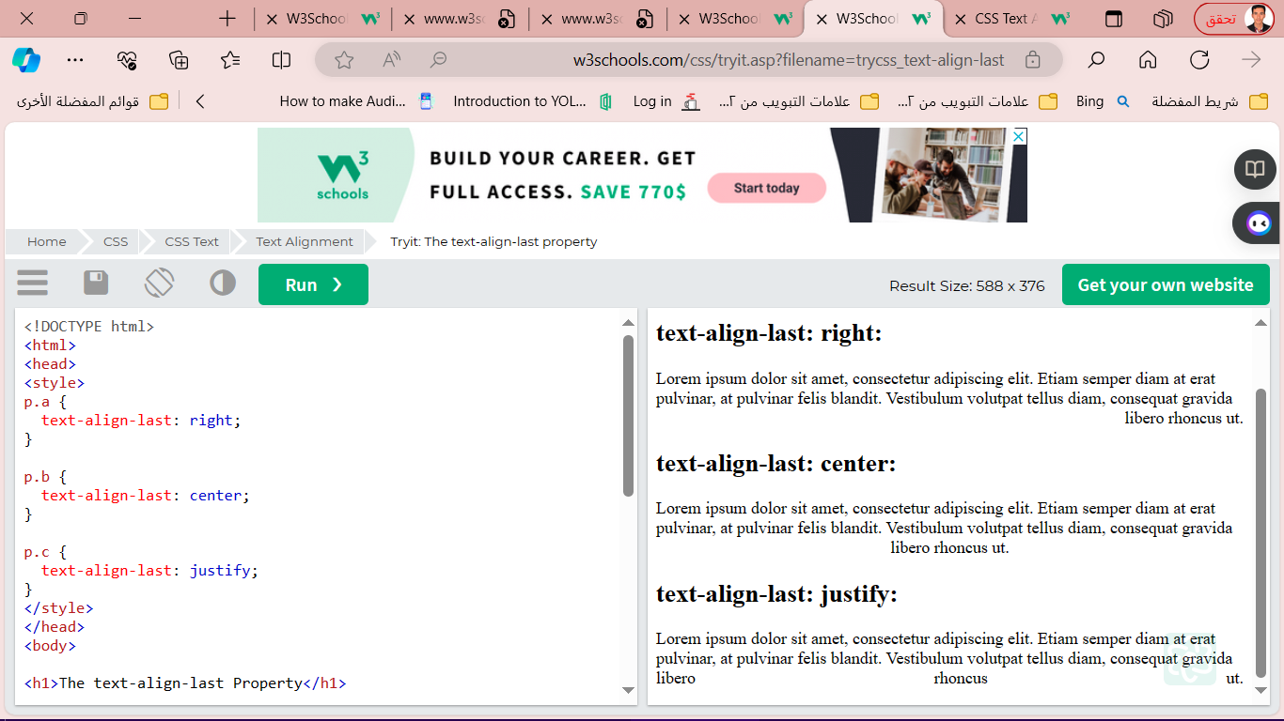**Example**

p.a {  
  text-align-last: right;  
}  
p.b {  
  text-align-last: center;  
}  
p.c {  
  text-align-last: justify;  
}

1. **Text Direction:** THE direction and unicode-bidi properties can be used to change the text direction of an element:

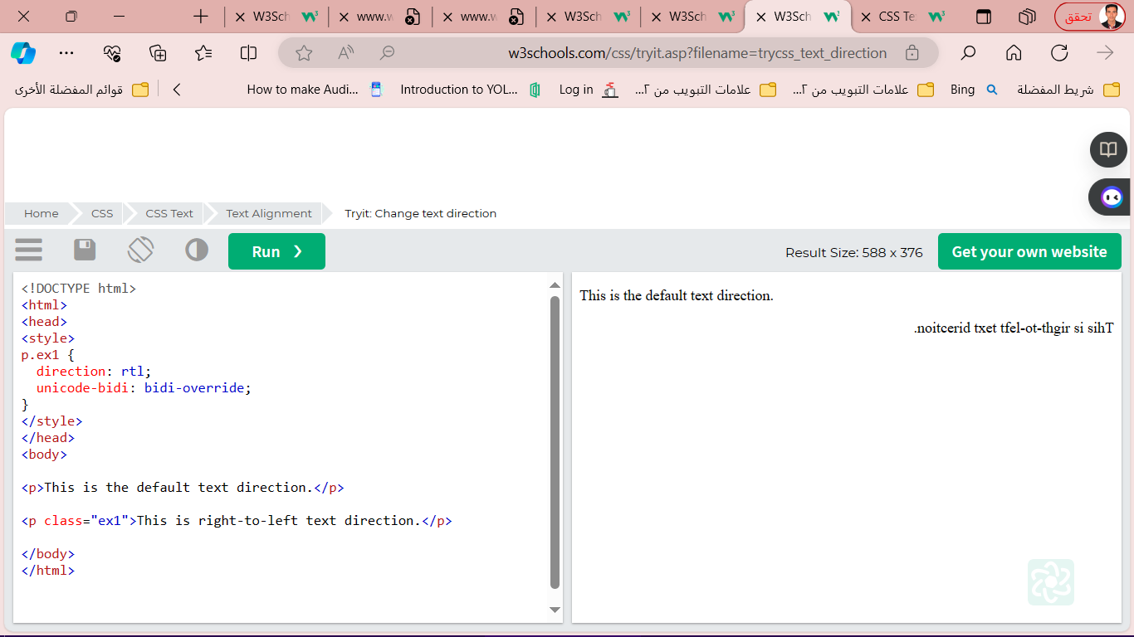

**Example**

p.ex1 {  
  direction: rtl;  
  unicode-bidi: bidi-override;  
}

<p class="ex1">This is right-to-left text direction.</p>

1. 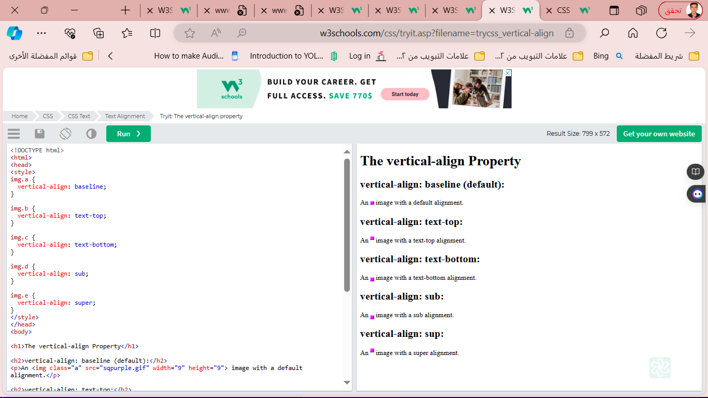**Vertical Alignment**

The vertical-align property sets the vertical alignment of an element.

img.a {  
 vertical-align: baseline;  
}  
img.b {  
 vertical-align: text-top;  
}  
img.c {  
 vertical-align: text-bottom;  
}  
img.d {  
 vertical-align: sub;  
}  
img.e {  
 vertical-align: super;  
}

* text-decoration-line
* text-decoration-color
* text-decoration-style
* text-decoration-thickness
* text-decoration

1. **CSS Text Decoration**

* **Add  Decoration Line to Text:**The text-decoration-line property is used to add a decoration line to text.

h1 {  
  text-decoration-line: overline;  
}  
h2 {  
  text-decoration-line: line-through;  
}  
h3 {  
  text-decoration-line: underline;  
}  
p {  
  text-decoration-line: overline underline;  
}

* **CSS Text Decoration**
* text-decoration-line
* text-decoration-color
* text-decoration-style
* text-decoration-thickness
* text-decoratio

**The text-decoration-line property is used**

**to add a decoration line to text.**

**Example**

h1 {  
  text-decoration-line: overline;  
}  
  
h2 {  
  text-decoration-line: line-through;  
}  
  
h3 {  
  text-decoration-line: underline;  
}  
  
p {  
  text-decoration-line: overline underline;  
}

**The text-decoration-color property is used to set the color of the decoration line.**

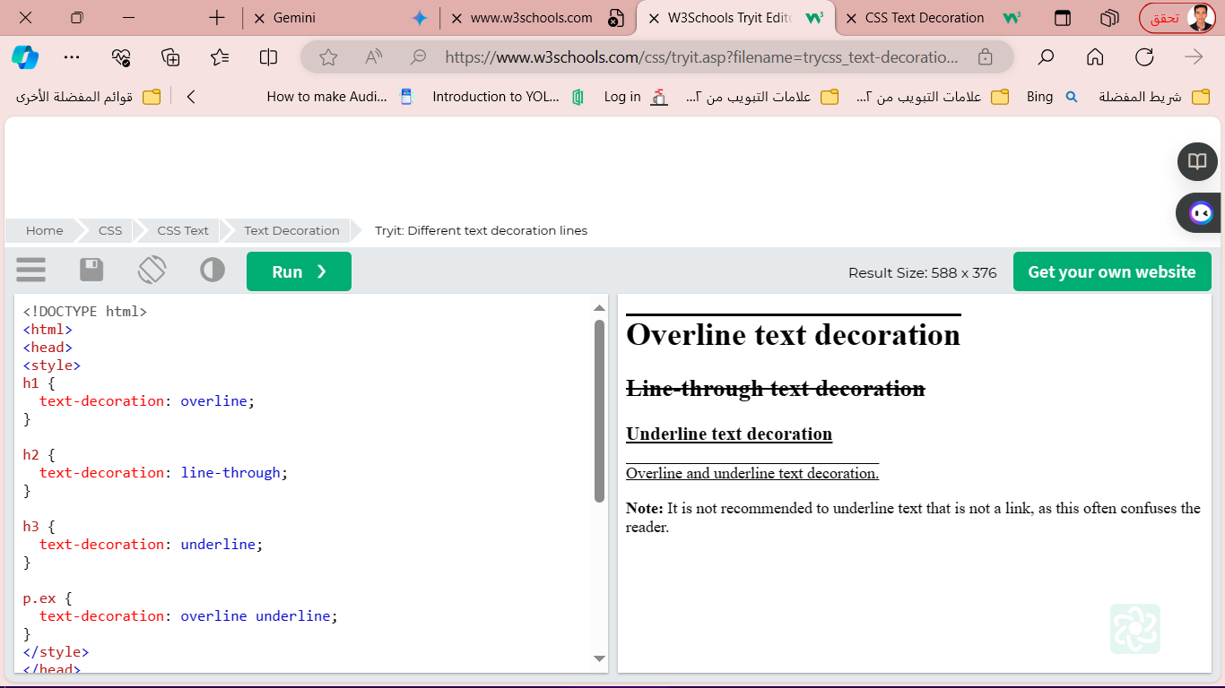

**Example**

h1 {  
  text-decoration-line: overline;  
  text-decoration-color: red;  
}  
  
h2 {  
  text-decoration-line: line-through;  
  text-decoration-color: blue;  
}  
  
h3 {  
  text-decoration-line: underline;  
  text-decoration-color: green;  
}  
  
p {  
  text-decoration-line: overline underline;  
  text-decoration-color: purple;  
}

**The text-decoration-style property is used to set the style of the decoration line.**

h1 {  
  text-decoration-line: underline;  
  text-decoration-style: solid;  
}  
h2 {  
  text-decoration-line: underline;  
  text-decoration-style: double;  
}  
h3 {  
  text-decoration-line: underline;  
  text-decoration-style: dotted;  
}  
p.ex1 {  
  text-decoration-line: underline;  
  text-decoration-style: dashed;  
}  
p.ex2 {  
  text-decoration-line: underline;  
  text-decoration-style: wavy;  
}  
p.ex3 {  
  text-decoration-line: underline;  
  text-decoration-color: red;  
  text-decoration-style: wavy;  
}

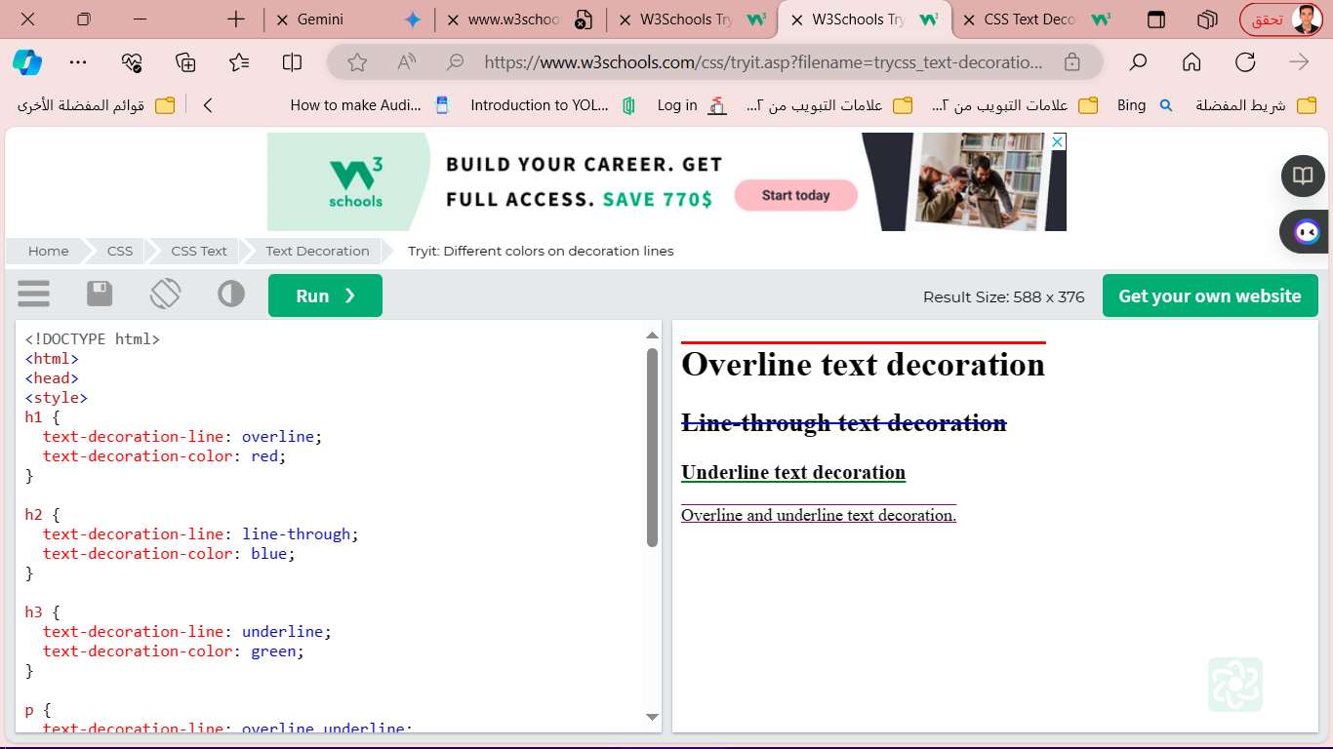

**The text-decoration-thickness property is used to set the thickness of the decoration line.**

**Example**

h1 {  
  text-decoration-line: underline;  
  text-decoration-thickness: auto;  
}  
h2 {  
  text-decoration-line: underline;  
  text-decoration-thickness: 5px;  
}  
h3 {  
  text-decoration-line: underline;  
  text-decoration-thickness: 25%;  
}  
p {  
  text-decoration-line: underline;  
  text-decoration-color: red;  
  text-decoration-style: double;  
  text-decoration-thickness: 5px;  
}

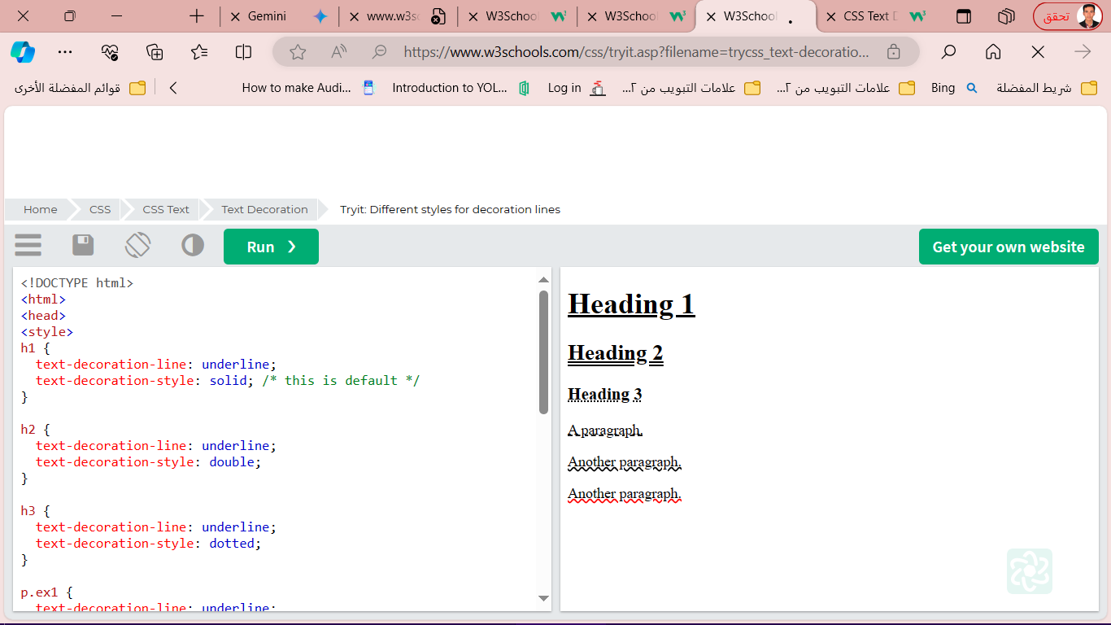

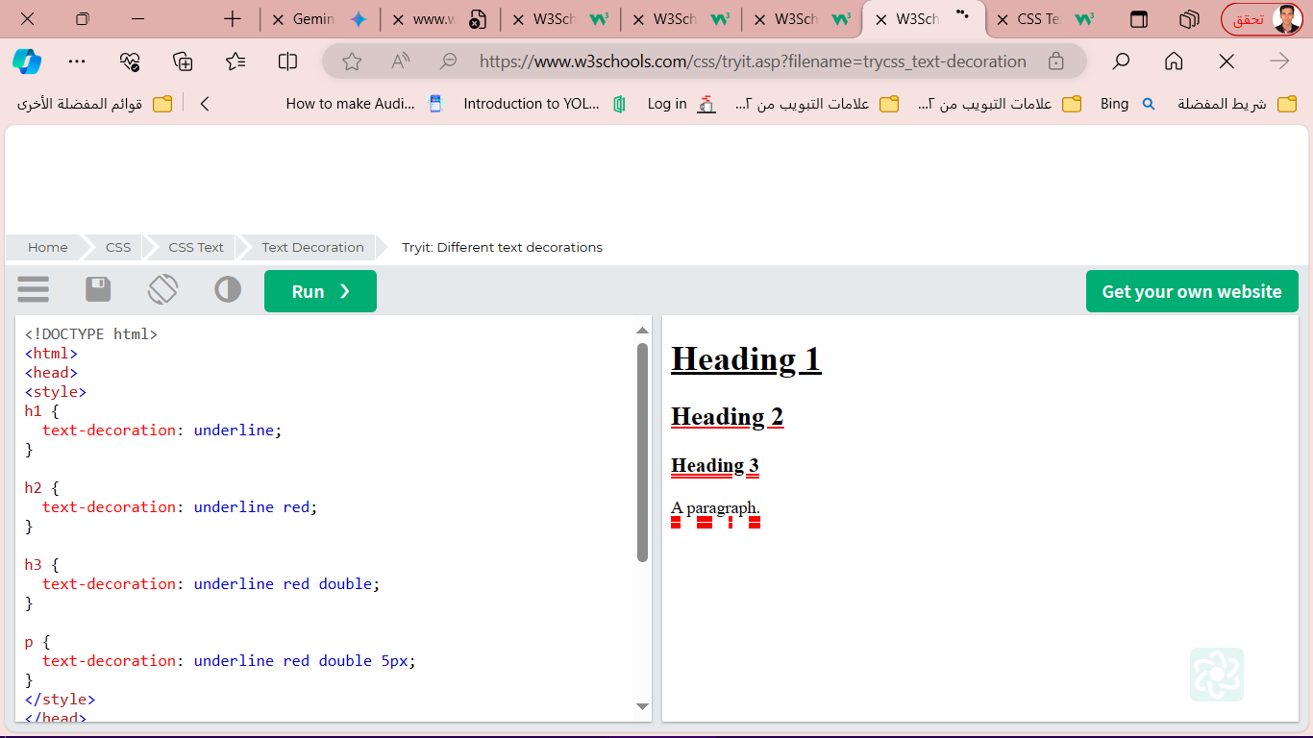**The text-decoration property is a shorthand property for:**

* text-decoration-line (required)
* text-decoration-color (optional)
* text-decoration-style (optional)
* text-decoration-thickness (optional)

**Example**

h1 {  
  text-decoration: underline;  
}  
h2 {  
  text-decoration: underline red;  
}  
h3 {  
  text-decoration: underline red double;  
}  
p {  
  text-decoration: underline red double 5px;  
}

* **CSS Text Transformation:**The text-transform property is used to specify uppercase and lowercase letters in a text.

**Example**

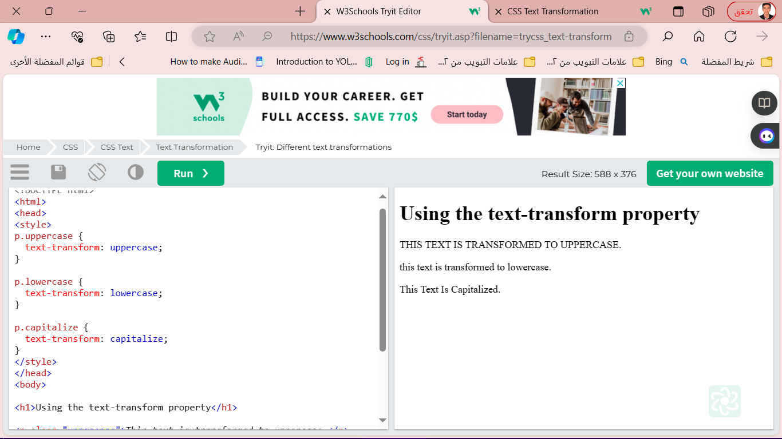p.uppercase {  
  text-transform: uppercase;  
}  
  
p.lowercase {  
  text-transform: lowercase;  
}  
  
p.capitalize {  
  text-transform: capitalize;  
}

* text-indent
* letter-spacing
* line-height
* word-spacing
* white-space

**- CSS Text** **Spacing**

* **CSS Text Shadow**

The text-shadow property adds shadow to text.

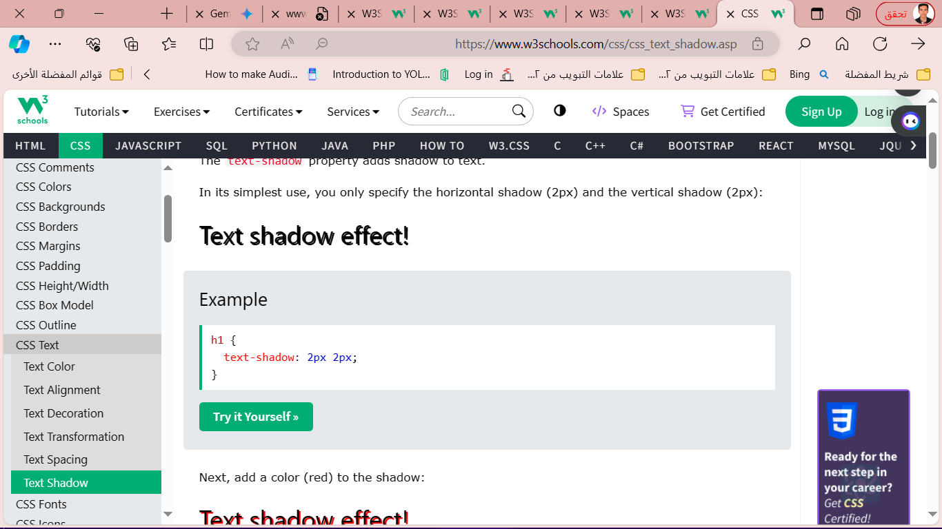**Example**

h1 {  
  text-shadow: 2px 2px;  
}

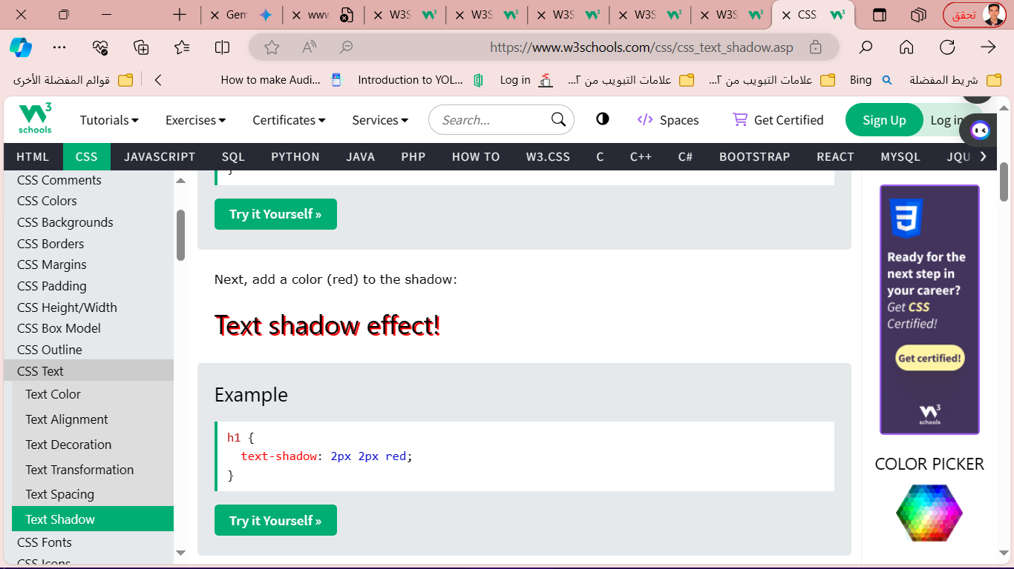**Example**

h1 {  
  text-shadow: 2px 2px red;  
}

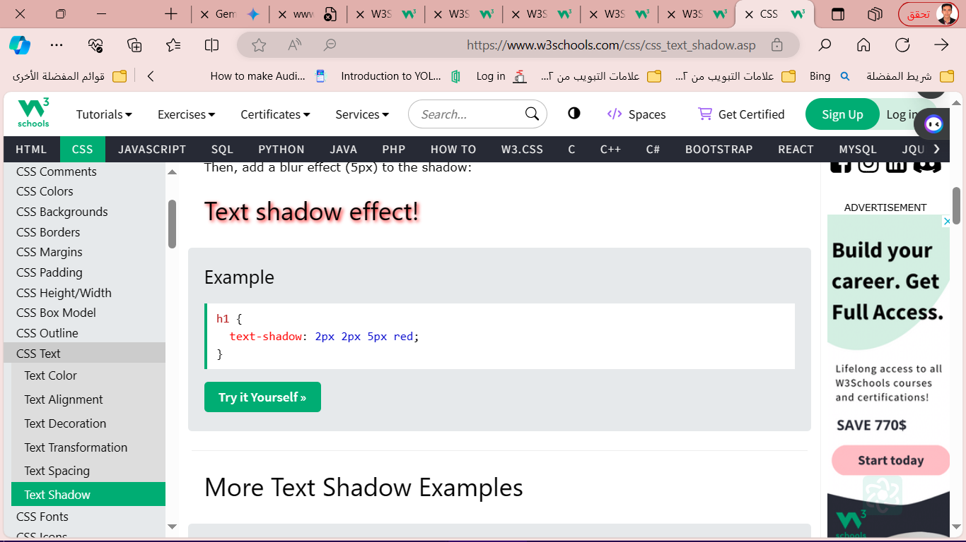**Example**

h1 {  
  text-shadow: 2px 2px 5px red;  
}

* **CSS Outline**

An outline is a line drawn outside the element's border.

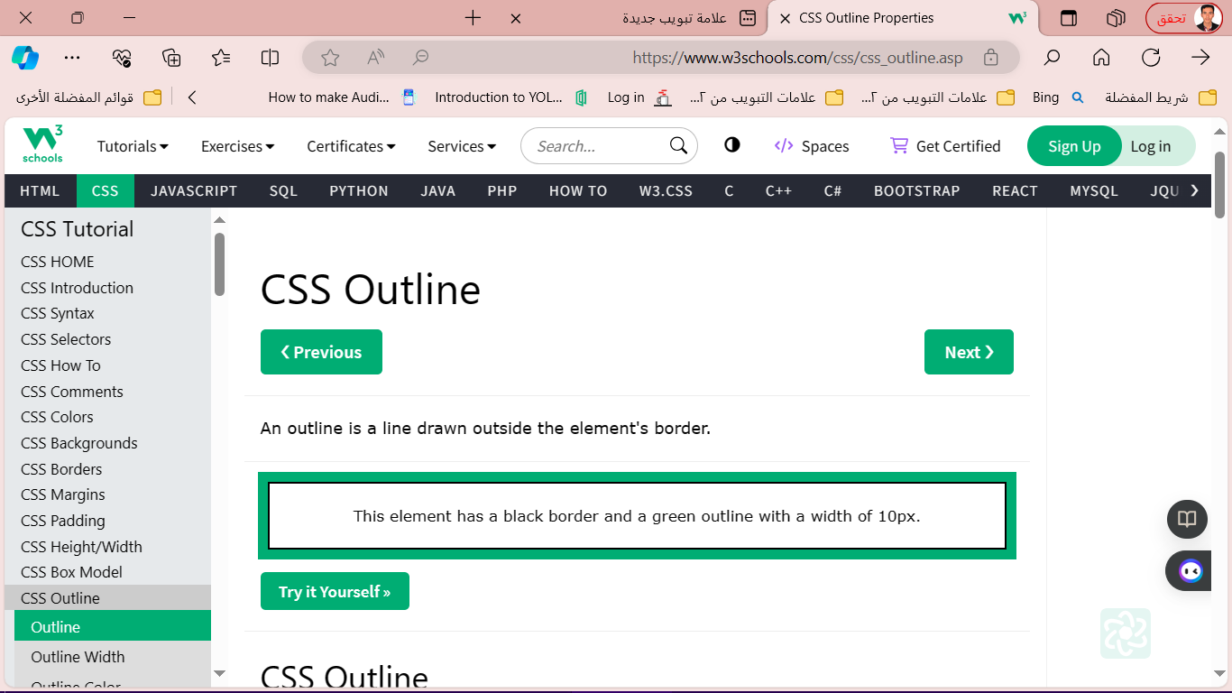

<style>

CSS has the following outline properties:

* outline-style
* outline-color
* outline-width
* outline-offset
* outline

p {

border: 2px solid black;

outline: #4CAF50 solid 10px;

margin: auto;

padding: 20px;

text-align: center;

}

</style>

<h2>CSS Outline</h2>

<p>This element has a 2px black border and a green outline with a width of 10px.</p>

* **CSS Outline Style**

p.dotted {outline-style: dotted;}  
p.dashed {outline-style: dashed;}  
p.solid {outline-style: solid;}  
p.double {outline-style: double;}  
p.groove {outline-style: groove;}  
p.ridge {outline-style: ridge;}  
p.inset {outline-style: inset;}  
p.outset {outline-style: outset;}

can have one of the following values:

* dotted - Defines a dotted outline
* dashed - Defines a dashed outline
* solid - Defines a solid outline
* double - Defines a double outline
* groove - Defines a 3D grooved outline
* ridge - Defines a 3D ridged outline
* 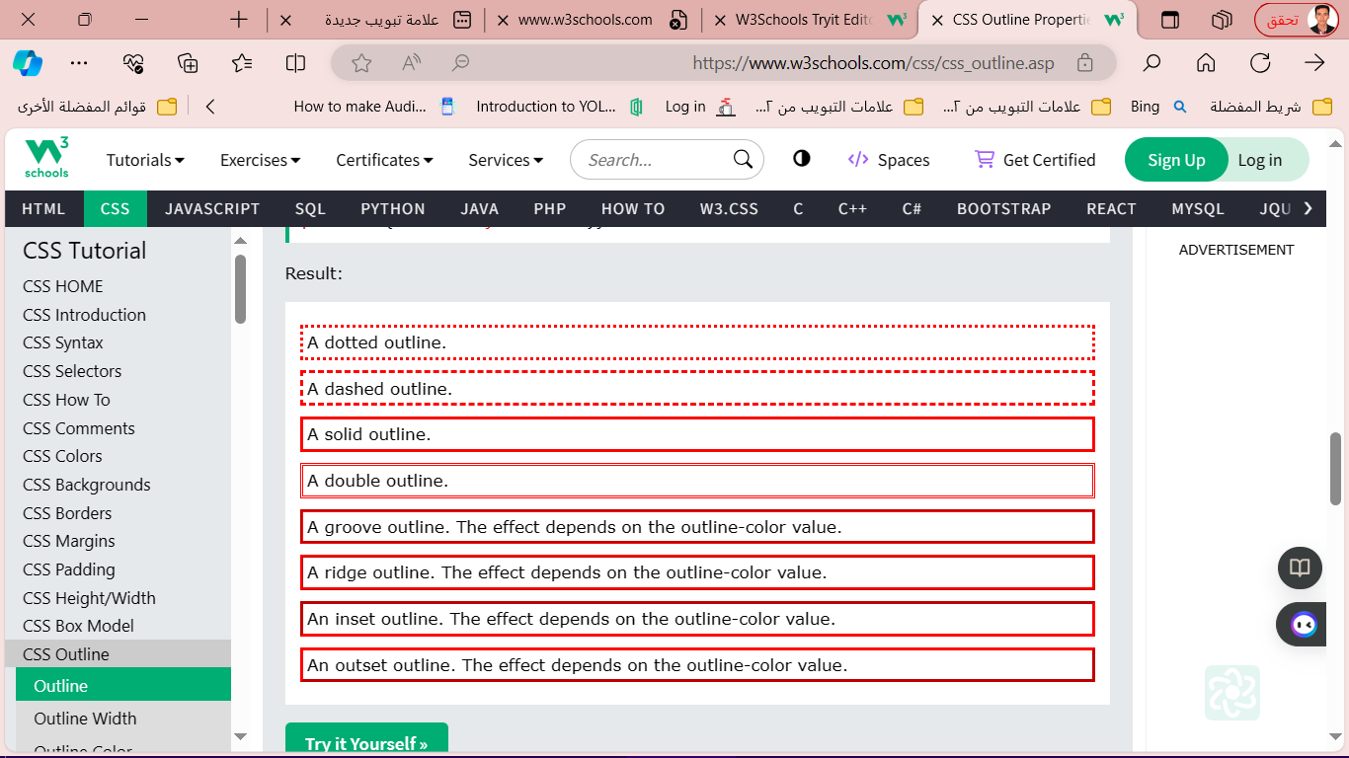inset - Defines a 3D inset outline
* outset - Defines a 3D outset outline
* none - Defines no outline
* hidden - Defines a hidden outline
* **CSS Outline Width**

can have one of the following values:

* thin (typically 1px)
* medium (typically 3px)
* thick (typically 5px)
* A specific size (in px, pt, cm, em, e

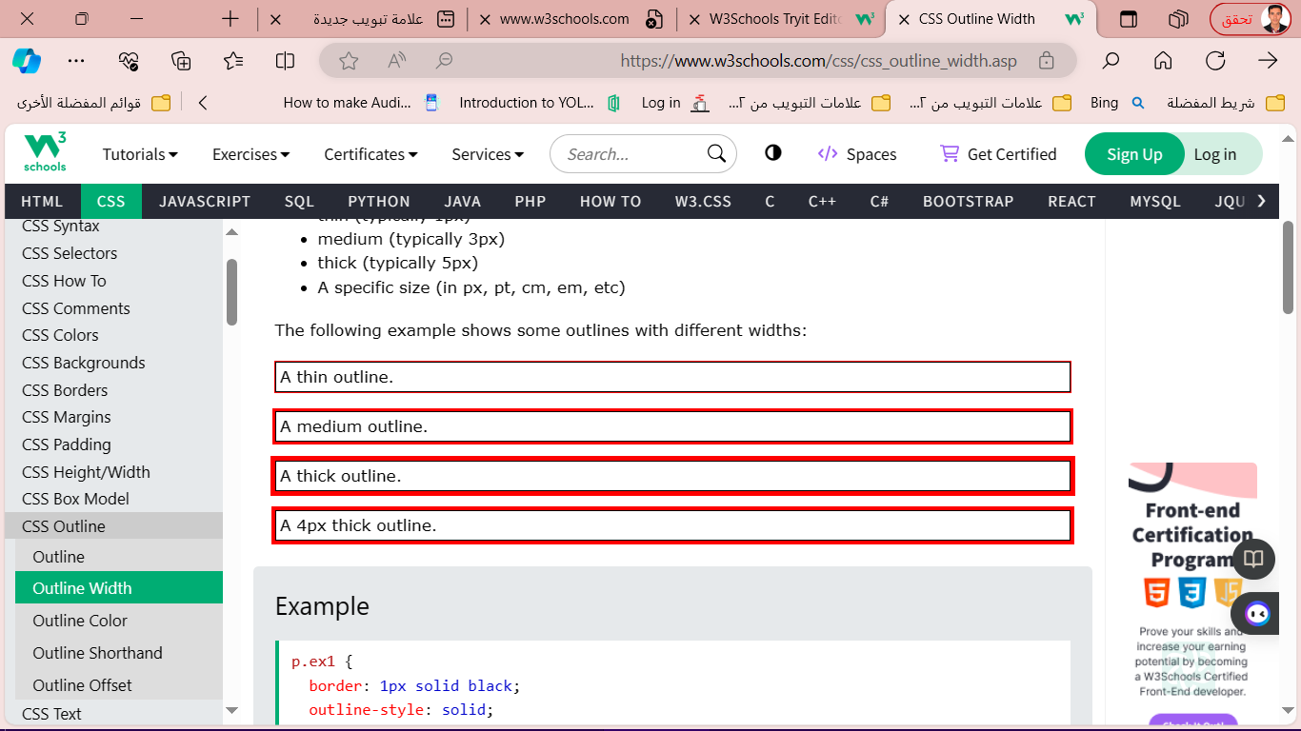

p.ex1 {  
  border: 1px solid black;  
  outline-style: solid;  
  outline-color: red;  
  outline-width: thin;  
}  
  
p.ex2 {  
  border: 1px solid black;  
  outline-style: solid;  
  outline-color: red;  
  outline-width: medium;  
}  
  
p.ex3 {  
  border: 1px solid black;  
  outline-style: solid;  
  outline-color: red;  
  outline-width: thick;  
}  
  
p.ex4 {  
  border: 1px solid black;  
  outline-style: solid;  
  outline-color: red;  
  outline-width: 4px;  
}

**in body:**

**<p class="ex1">A thin outline.</p>**

**<p class="ex2">A medium outline.</p>**

**<p class="ex3">A thick outline.</p>**

**<p class="ex4">A 4px thick outline.</p>**

* **CSS Outline Color:** The outline-color property is used to set the color of the outline.

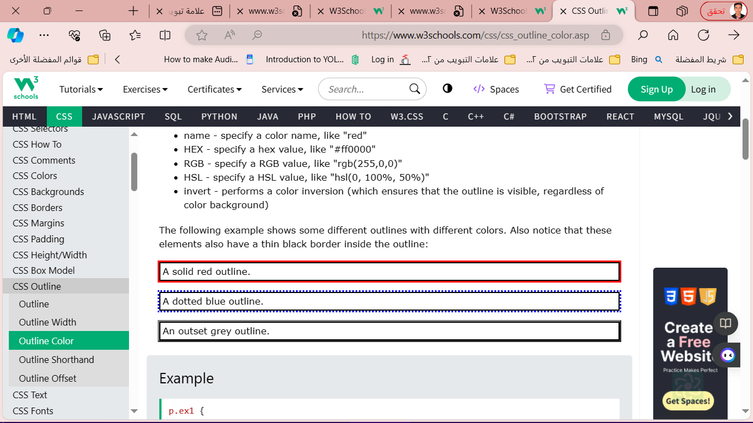

p.ex1 {  
  border: 2px solid black;  
  outline-style: solid;  
  outline-color: red;  
}  
  
p.ex2 {  
  border: 2px solid black;  
  outline-style: dotted;  
  outline-color: blue;  
}  
  
p.ex3 {  
  border: 2px solid black;  
  outline-style: outset;  
  outline-color: grey;  
}

* **CSS Outline - Shorthand property:** The outline property is a shorthand property for setting the following individual outline properties:
* outline-width
* outlinestyle (require)
* outline-color

p.ex1 {outline: dashed;}  
p.ex2 {outline: dottedred;}  
p.ex3 {outline: 5px solid yellow;}

p.ex4 {outline: thick ridge pink;}

* **CSS Outline Offse:**

خاصية outline-offset تضيف مسافة بين الخط الخارجي (outline) وحافة العنصر أو حدوده. المسافة بين العنصر والخط الخارجي شفافة

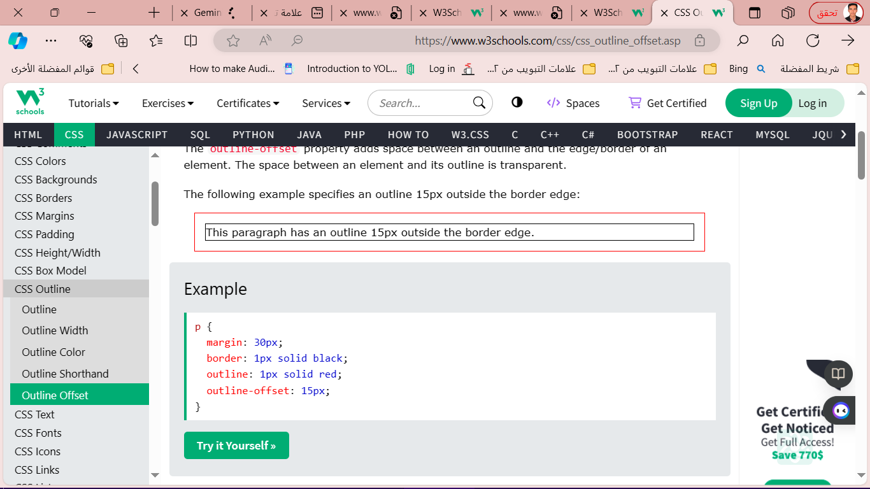

p {  
  margin: 30px;  
  border: 1px solid black;

  outline: 1px solid red;  
  outline-offset: 15px;

1. **CSS Fonts**

Font Selection is Important

**Generic Font Families**

In CSS there are five generic font families:

1. **Serif** fonts have a small stroke at the edges of each letter. They create a sense of formality and elegance.
2. **Sans-serif** fonts have clean lines (no small strokes attached). They create a modern and minimalistic look.
3. **Monospace** fonts - here all the letters have the same fixed width. They create a mechanical look.
4. **Cursive** fonts imitate human handwriting.
5. **Fantasy** fonts are decorative/playful fonts.

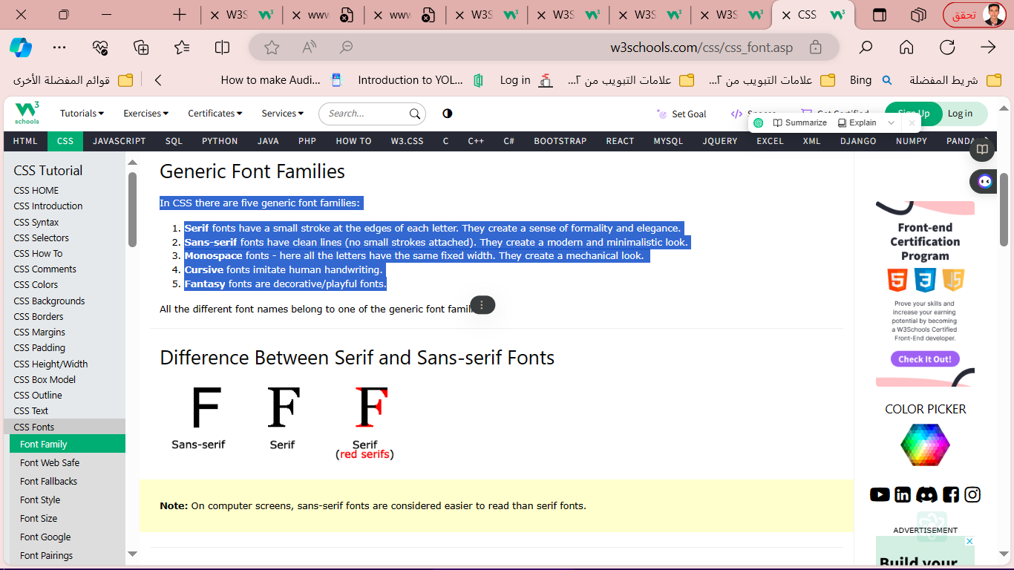

Font Examples

|  |  |
| --- | --- |
| Generic Font Family | Examples of Font Names |
| Serif | Times New Roman,Georgia ,Garamond |
| Sans-serif | Arial,Verdana, Helvetica |
| Monospace | Courier New,Lucida Console, Monaco |
| Cursive | Brush Script MT, Lucida Handwriting |
| Fantasy | Copperplate, Papyrus |

**CSS font-family Property**

In CSS, we use the font-family property to specify the font of a text.

.p1 {  
  font-family: "Times New Roman", Times, serif;

}  
  
.p2 {  
  font-family: Arial, Helvetica, sans-serif;

}  
  
.p3 {  
  font-family: "Lucida Console", "Courier New", monospace;

}

**CSS Web Safe Fonts**

Web safe fonts are fonts that are universally installed across all browsers and devices.

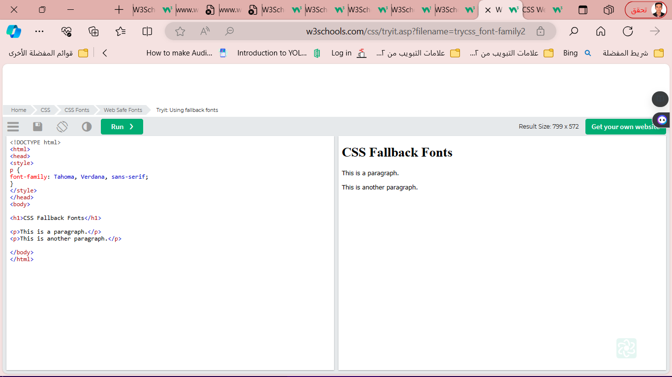**Fallback Fonts**

p {  
font-family: Tahoma, Verdana, sans-serif;

}

**Best Web Safe Fonts for HTML and CSS**

best web safe fonts for HTML and CSS:

* Arial (sans-serif)
* Verdana (sans-serif)
* Tahoma (sans-serif)
* Trebuchet MS (sans-serif)
* Times New Roman (serif)
* Georgia (serif)
* Garamond (serif)
* Courier New (monospace)
* Brush Script MT (cursiv(

1. 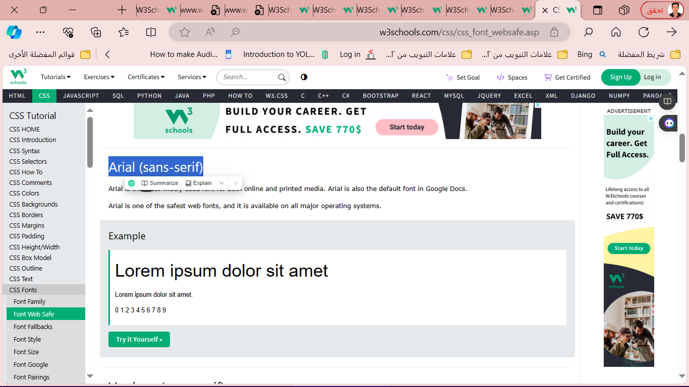Arial (sans-serif)

body {

font-family: Arial, sans-serif;

}

1. Verdana (sans-serif)

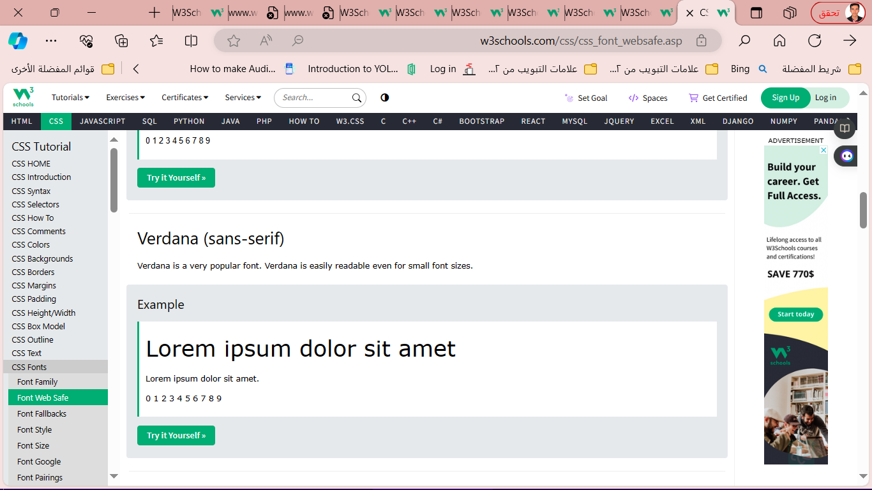body {

font-family: Verdana, sans-serif;

}

1. **Tahoma (sans-serif)**

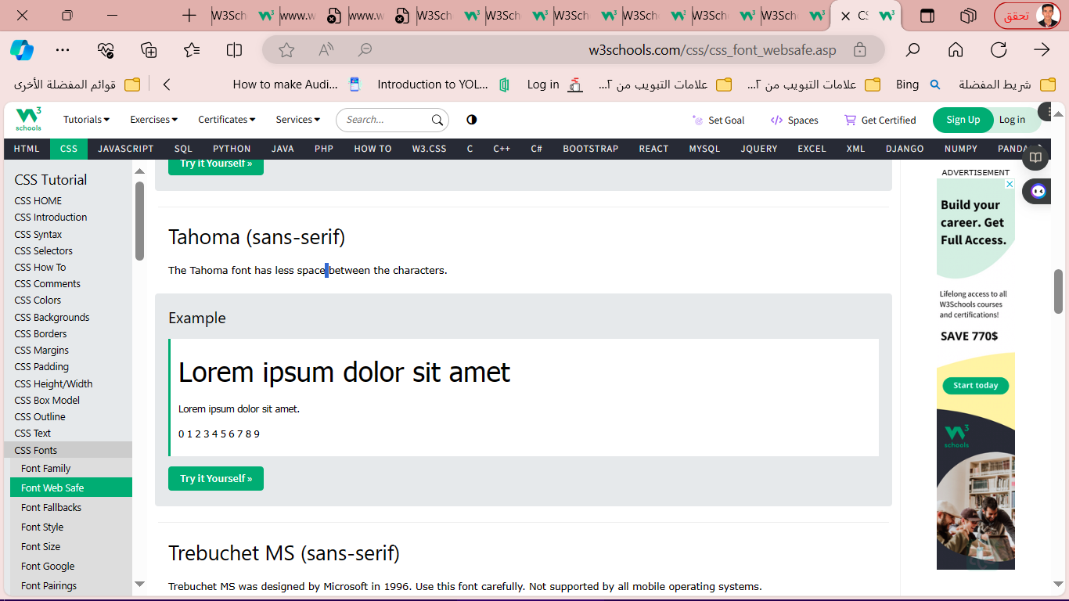body {

font-family: Tahoma, sans-serif;

}

1. **Trebuchet MS (sans-serif)**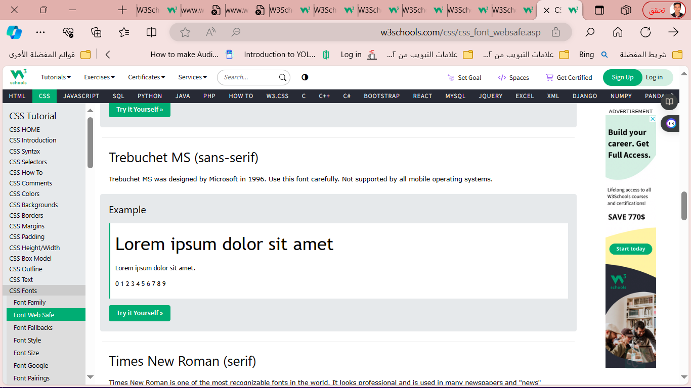

body {

font-family: 'Trebuchet MS', sans-serif;

}

1. **Times New Roman (serif)**

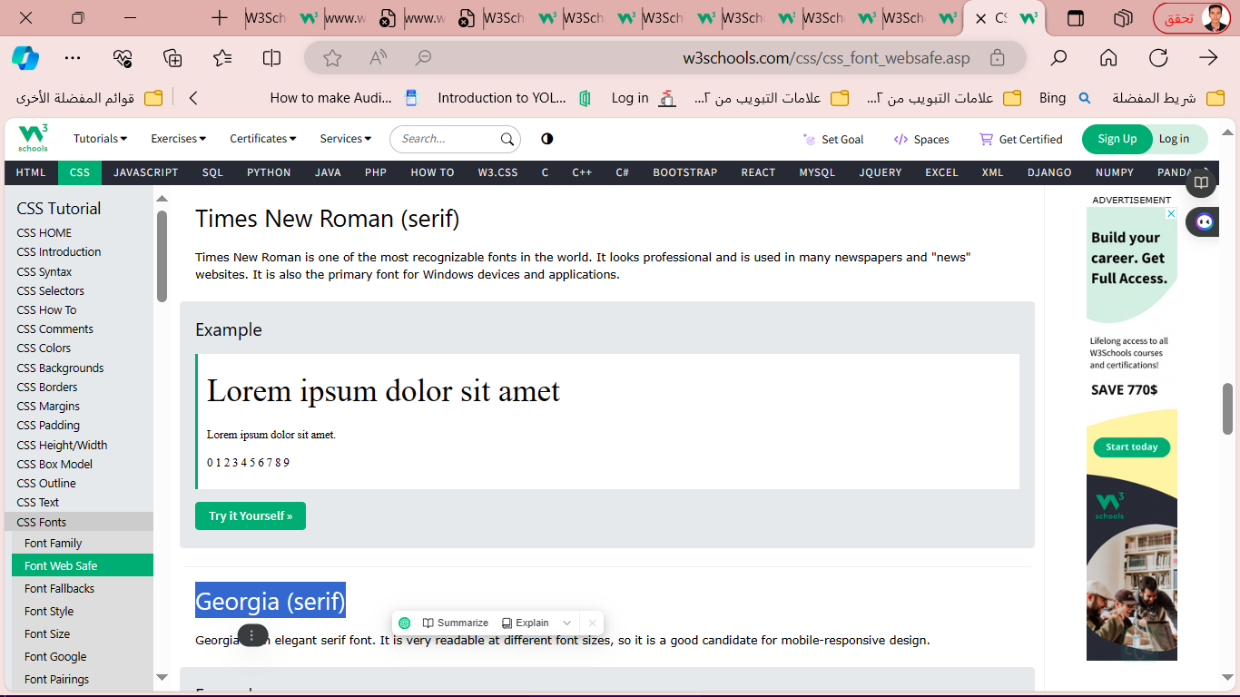

1. Georgia (serif)

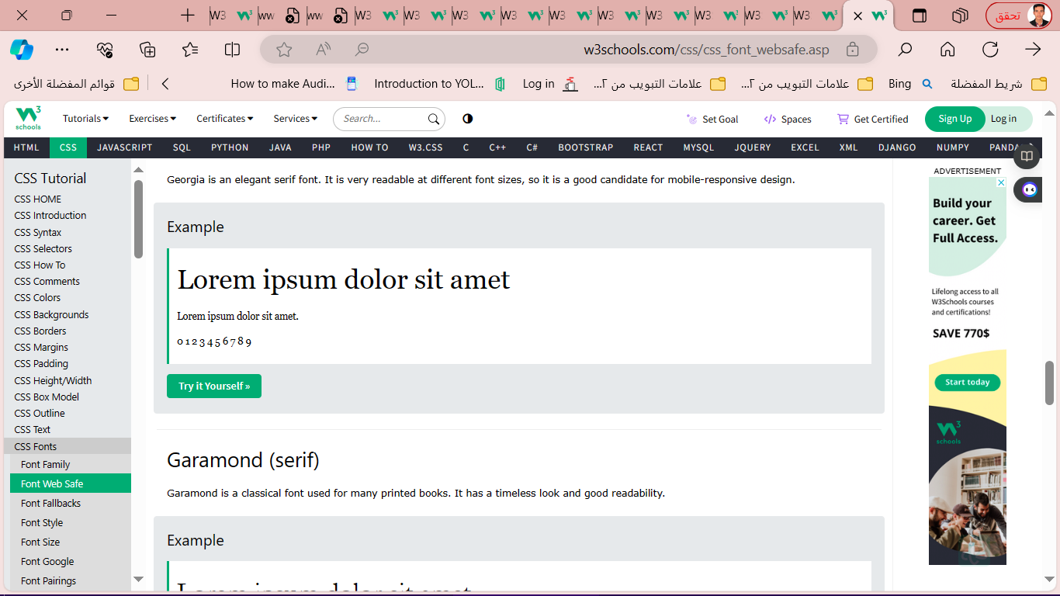

1. Garamond (serif)

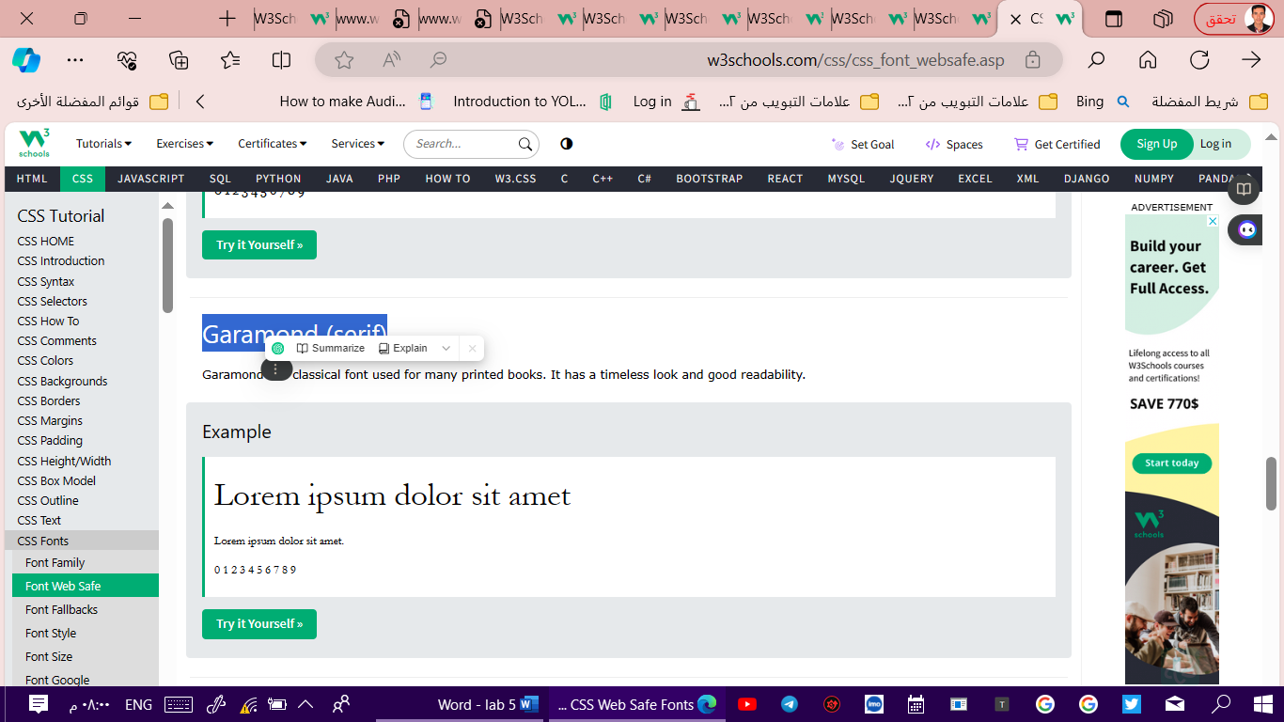

1. Courier New (monospace)

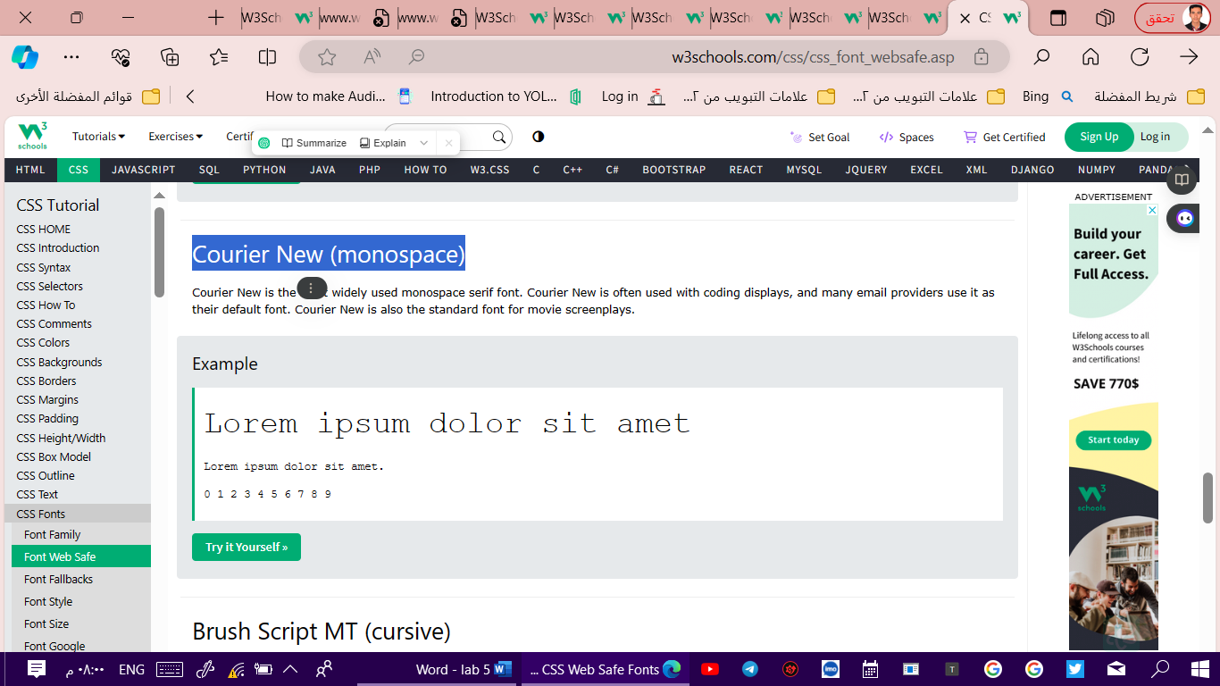

1. Brush Script MT (cursive)

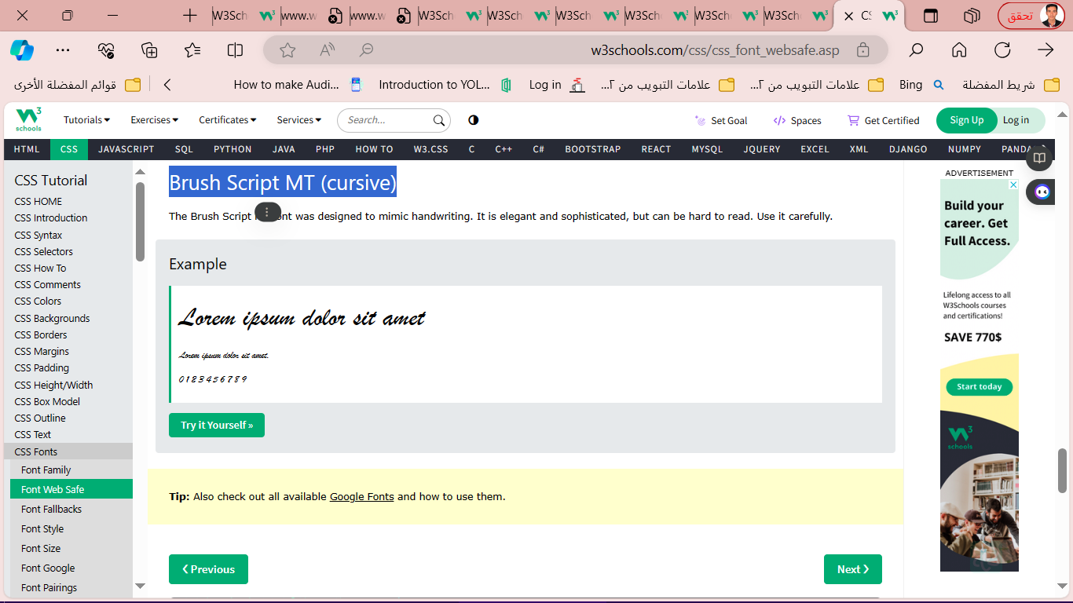

* **CSS Font Style**

The font-style property is mostly used to specify italic text.

 three values:

* normal - The text is shown normally
* italic - The text is shown in italics
* oblique - The text is "leaning" (oblique is very similar to italic, but less supported)

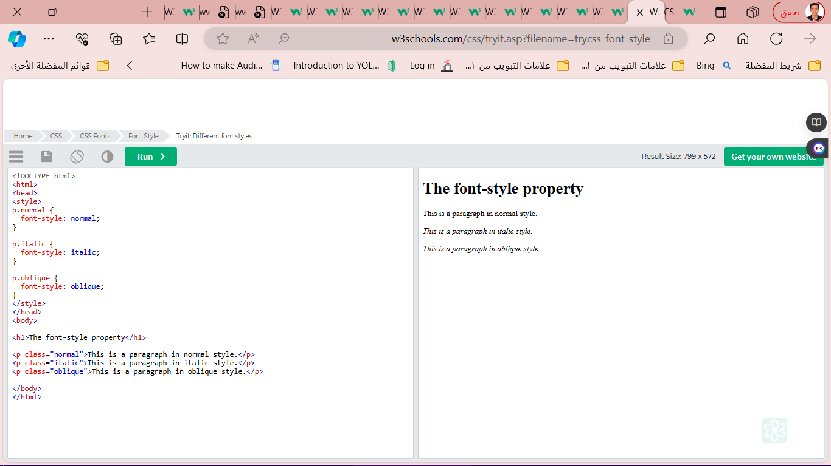p.normal {  
  font-style: normal;  
}  
p.italic {  
  font-style: italic;  
}  
p.oblique {  
  font-style: oblique;  
}

* Font Weight

p.normal {  
  font-weight: normal;  
}  
  
p.thick {  
  font-weight: bold;  
}

* **Font Variant**

p.normal {  
  font-variant: normal;  
}  
  
p.small {  
  font-variant: small-caps;  
}

* **CSS Font Size**

The font-size property sets the size of the text.

h1 {  
  font-size: 40px;  
}

h1 {  
  font-size: 2.5em; /* 40px/16=2.5em */  
}

body {  
  font-size: 100%;  
}

* **CSS Google Fonts**

If you do not want to use any of the standard fonts in HTML, you can use Google Fonts.

Google Fonts are free to use, and have more than 1000 fonts to choose from.

How To Use Google Fonts

<head>  
**<link rel="stylesheet" href="https://fonts.googleapis.com/css?family=Sofia">**  
<style>  
body {  
  font-family: "Sofia", sans-serif;  
}  
</style>  
</head>

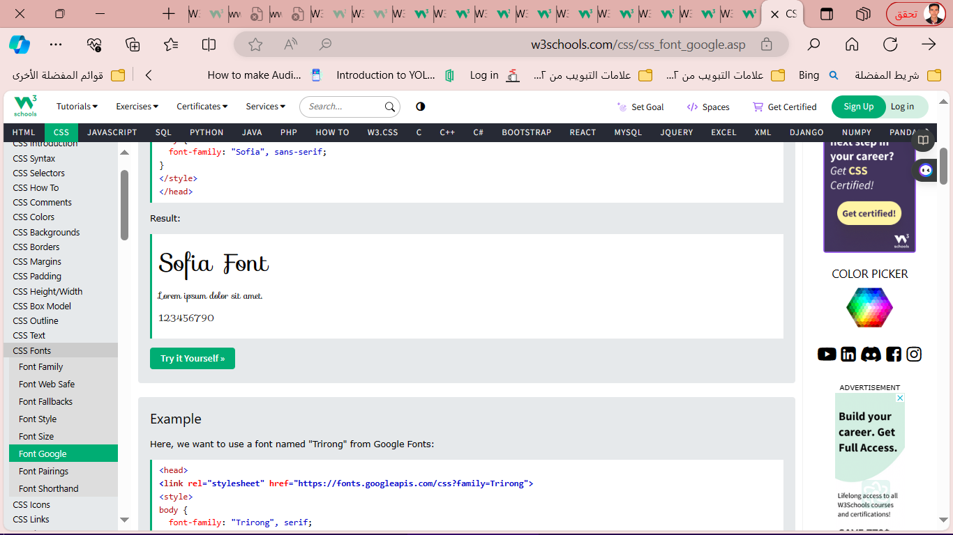

* **Enabling Font Effects**

Google has also enabled different font effects that you can use.

<head>  
**<link rel="stylesheet" href="https://fonts.googleapis.com/css?family=Sofia&effect=fire">**  
<style>  
body {  
  font-family: "Sofia", sans-serif;  
  font-size: 30px;  
}  
</style>  
</head>  
<body>  
  
<h1 class="font-effect-fire">Sofia on Fire</h1>  
  
</body>

Result:

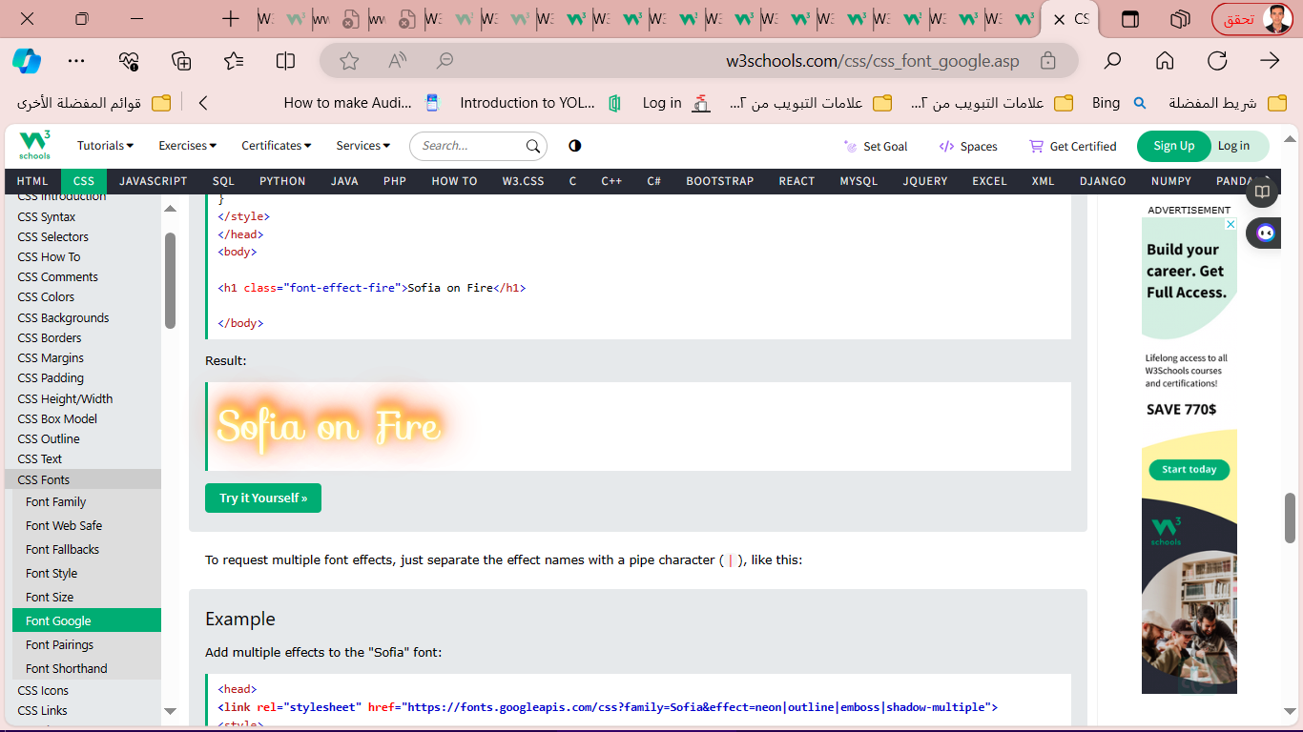

**multiple font effects**

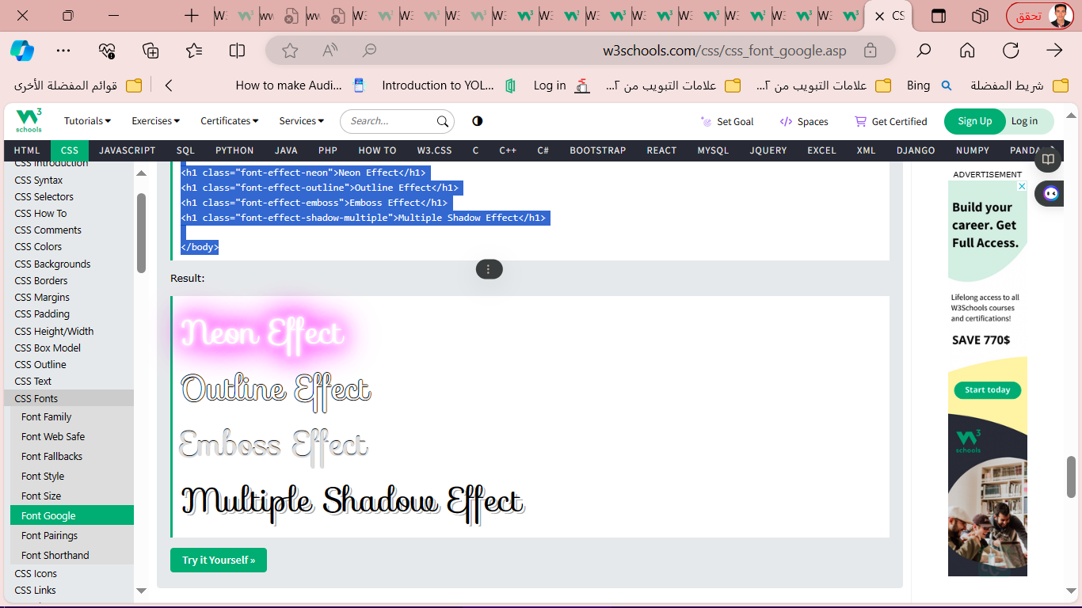<head>  
**<link rel="stylesheet" href="https://fonts.googleapis.com/css?family=Sofia&effect=neon|outline|emboss|shadow-multiple">**  
<style>  
body {  
  font-family: "Sofia", sans-serif;  
  font-size: 30px;  
}  
</style>  
</head>  
<body>  
<h1 class="font-effect-neon">Neon Effect</h1>  
<h1 class="font-effect-outline">Outline Effect</h1>  
<h1 class="font-effect-emboss">Emboss Effect</h1>  
<h1 class="font-effect-shadow-multiple">Multiple Shadow Effect</h1>  
  
</body>

* **CSS Font Property**

 font property is a shorthand property for:

* font-style
* font-variant
* font-weight
* font-size/line-height
* font-family

p.a {  
  font: 20px Arial, sans-serif;  
}

* **CSS Icons :**Icons can easily be added to your HTML page, by using an icon library.

**إضافة أيقونة, اتبع الخطوات التالية:**

1. **اختر مكتبة أيقونات: هناك العديد من مكتبات الأيقونات المجانية والمدفوعة المتاحة, بما في ذلك Font Awesome, Material Design Icons, and Bootstrap Icons. اختر المكتبة التي توفر الأيقونات التي تحتاجها وتتناسب مع تصميم موقع الويب الخاص بك.**
2. **احصل على كود الأيقونة: بمجرد اختيار مكتبة الأيقونات, ستحتاج إلى الحصول على كود الأيقونة التي تريد استخدامها. عادةً ما توفر مكتبات الأيقونات مواقع ويب أو وثائق حيث يمكنك استعراض الأيقونات المتاحة ونسخ كود الأيقونة المطلوب.**
3. **أضف كود الأيقونة إلى HTML الخاص بك: بعد الحصول على كود الأيقونة, أضفه إلى عنصر HTML مضمن في صفحتك. غالبًا ما تستخدم العناصر <i> أو <span> لهذا الغرض. على سبيل المثال, لإضافة أيقونة نجمة باستخدام Font Awesome, يمكنك استخدام الكود التالي:**

**Example**

<!DOCTYPE html>  
<html>  
<head>  
<script src="https://kit.fontawesome.com/a076d05399.js" crossorigin="anonymous"></script>  
</head>  
<body>  
<i class="fas fa-cloud"></i>  
<i class="fas fa-heart"></i>  
<i class="fas fa-car"></i>  
<i class="fas fa-file"></i>  
<i class="fas fa-bars"></i>  
</body>  
</html>

**Bootstrap Icons**

<!DOCTYPE html>  
<html>  
<head>  
<link rel="stylesheet" href="https://maxcdn.bootstrapcdn.com/bootstrap/3.3.7/css/bootstrap.min.css">  
</head>  
<body>  
<i class="glyphicon glyphicon-cloud"></i>  
<i class="glyphicon glyphicon-remove"></i>  
<i class="glyphicon glyphicon-user"></i>  
<i class="glyphicon glyphicon-envelope"></i>  
<i class="glyphicon glyphicon-thumbs-up"></i>  
  
</body>  
</html>

## **Google Icons**

<!DOCTYPE html>  
<html>  
<head>  
<link rel="stylesheet" href="https://fonts.googleapis.com/icon?family=Material+Icons">  
</head>  
<body>  
<i class="material-icons">cloud</i>  
<i class="material-icons">favorite</i>  
<i class="material-icons">attachment</i>  
<i class="material-icons">computer</i>  
<i class="material-icons">traffic</i>  
  
</body>  
</html>

* **CSS Links**

With CSS, links can be styled in many different ways.

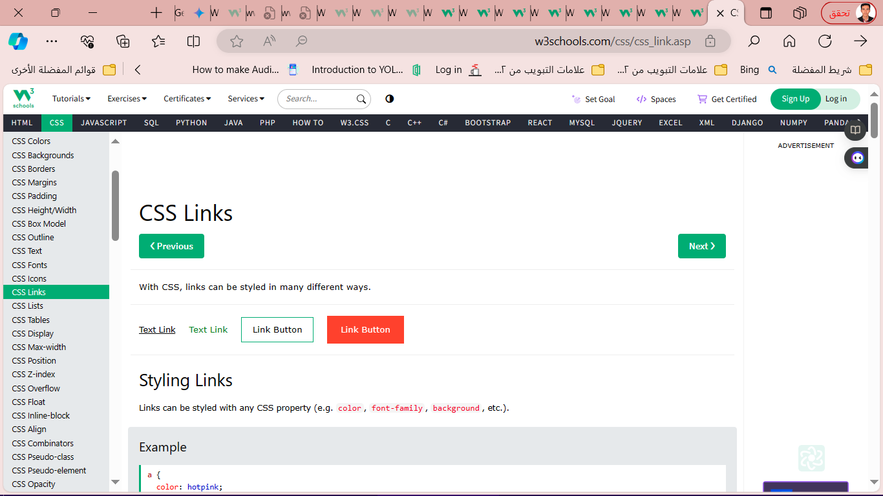

**Styling Links**

Links can be styled with any CSS property (e.g. color, font-family, background, etc.).

a {  
  color: hotpink;  
}

The four links states are:

* a:link - a normal, unvisited link
* a:visited - a link the user has visited
* a:hover - a link when the user mouses over it
* a:active - a link the moment it is clicked

/* unvisited link */

a:link {  
  color: red;

}  
  
/* visited link */

a:visited {  
  color: green;

}  
  
/* mouse over link */

a:hover {  
  color: hotpink;  
}  
  
/* selected link */

a:active {  
  color: blue;

}

* **Link Buttons**

**Example**

a:link, a:visited {  
  background-color: #f44336;  
  color: white;  
  padding: 14px 25px;  
  text-align: center;  
  text-decoration: none;  
  display: inline-block;  
}  
  
a:hover, a:active {  
  background-color: red;  
}

* **More Examples**

**Example**

This example demonstrates how to add other styles to hyperlinks:

a.one:link {color: #ff0000;}  
a.one:visited {color: #0000ff;}  
a.one:hover {color: #ffcc00;}  
  
a.two:link {color: #ff0000;}  
a.two:visited {color: #0000ff;}  
a.two:hover {font-size: 150%;}  
  
a.three:link {color: #ff0000;}  
a.three:visited {color: #0000ff;}  
a.three:hover {background: #66ff66;}  
  
a.four:link {color: #ff0000;}  
a.four:visited {color: #0000ff;}  
a.four:hover {font-family: monospace;}  
  
a.five:link {color: #ff0000; text-decoration: none;}  
a.five:visited {color: #0000ff; text-decoration: none;}  
a.five:hover {text-decoration: underline;}

* **CSS Lists**

**Unordered Lists:**

* Coffee
* Tea
* Coca Cola
* Coffee
* Tea
* Coca Cola

**Ordered Lists:**

1. Coffee
2. Tea
3. Coca Cola
4. Coffee
5. Tea
6. Coca

list-style-type property specifies the type of list item marker.

**Example**

ul.a {  
  list-style-type: circle;  
}  
  
ul.b {  
  list-style-type: square;  
}  
  
ol.c {  
  list-style-type: upper-

roman;  
}  
  
ol.d {  
  list-style-type: lower-alpha;  
}

* **An Image as The List Item Marker**

ul {  
  list-style-image: url('sqpurple.gif');  
}

* **Position The List Item Markers**

ul.a {  
  list-style-position: outside;  
}  
  
ul.b {  
  list-style-position: inside;  
}

**Remove Default Settings**

The list-style-type:none property can also be used to remove the markers/bullets. Note that the list also has default margin and padding. To remove this, add margin:0 and padding:0 to <ul> or <ol>:

**Example**

ul {  
  list-style-type: none;  
  margin: 0;  
  padding: 0;  
}

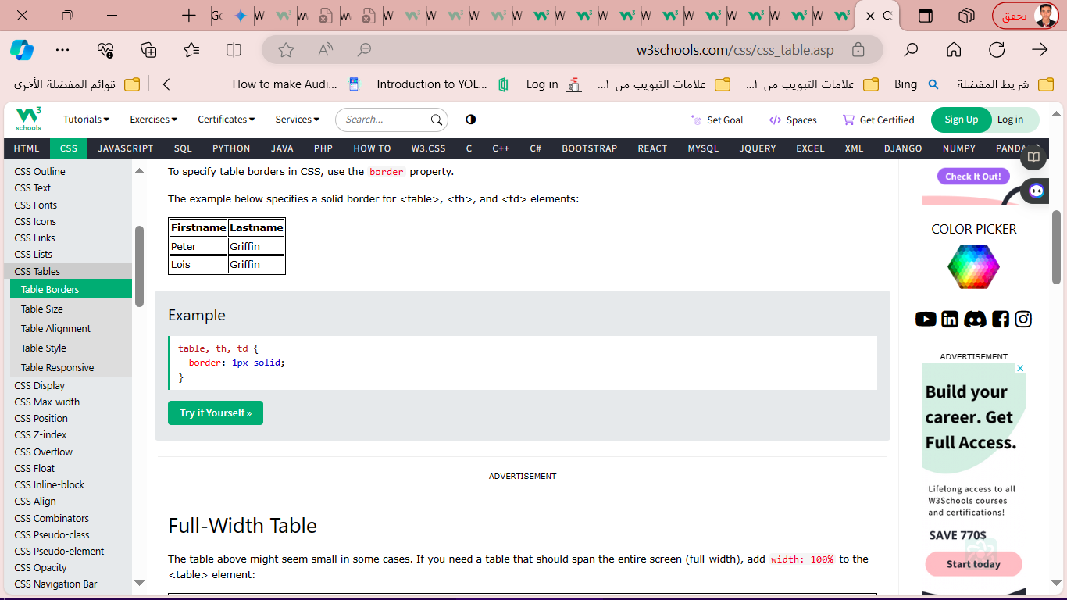

* **CSS Tables**
* **Table Borders**

table, th, td {  
  border: 1px solid;  
}

**Full-Width Table**

The table above might seem small in some cases. If you need a table that should span the entire screen (full-width), add width: 100% to the <table > element:

**Example**

table {  
  width: 100%;  
}

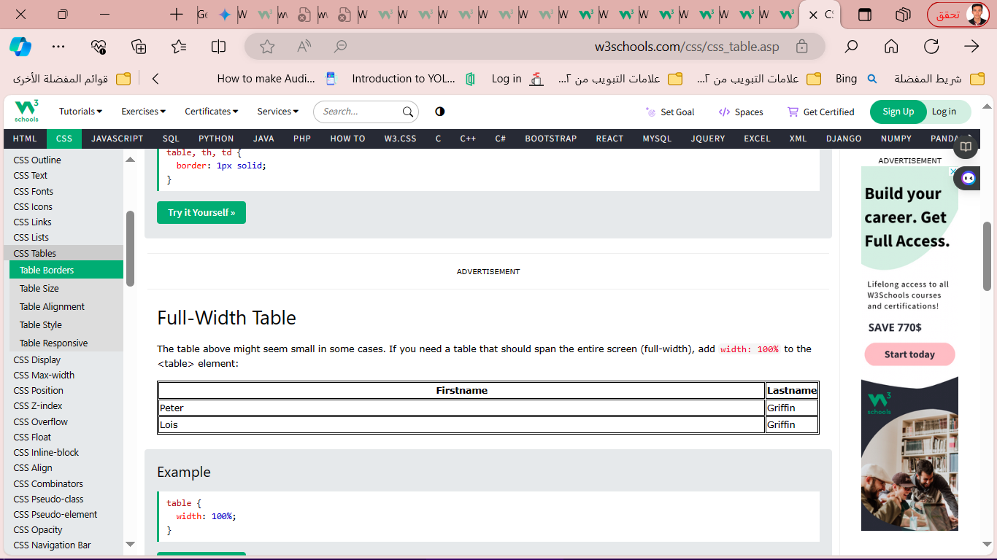

* **Collapse Table Borders**

The border-collapse property sets whether the table borders should be collapsed into a single border:

**Example**

table {  
  border-collapse: collapse;  
}

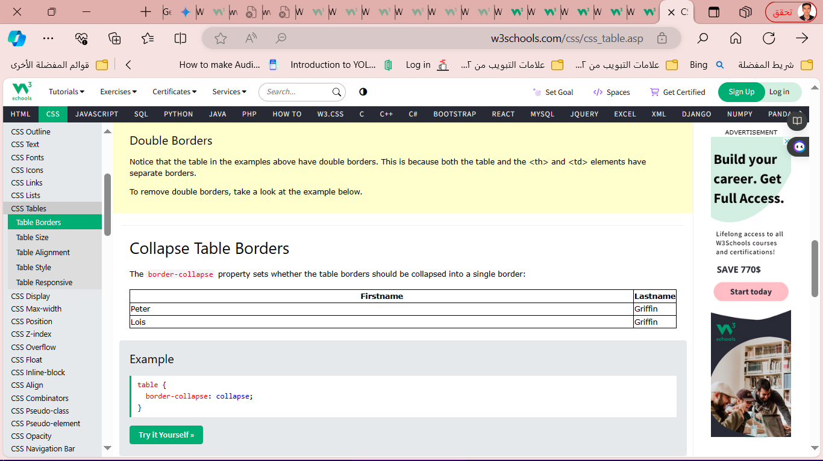

* **CSS Table Size**

**Table Width and Height:** The width and height of a table are defined by the width and height properties.

The example below sets the width of the table to 100%, and the height of the <th> elements to 70px:

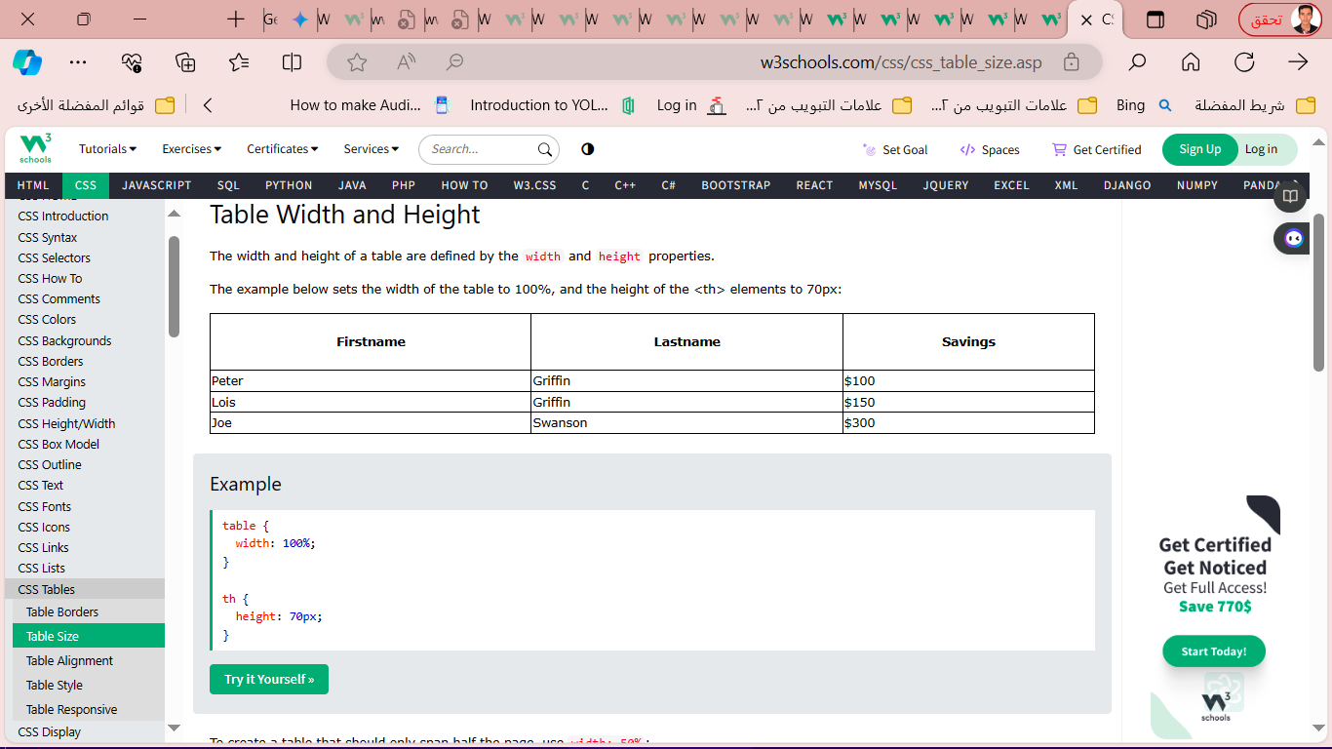

**Example**

table {  
  width: 100%;  
}  
  
th {  
  height: 70px;  
}

**CSS Table Alignment**

* **Horizontal Alignment**

td {  
  text-align: center;}

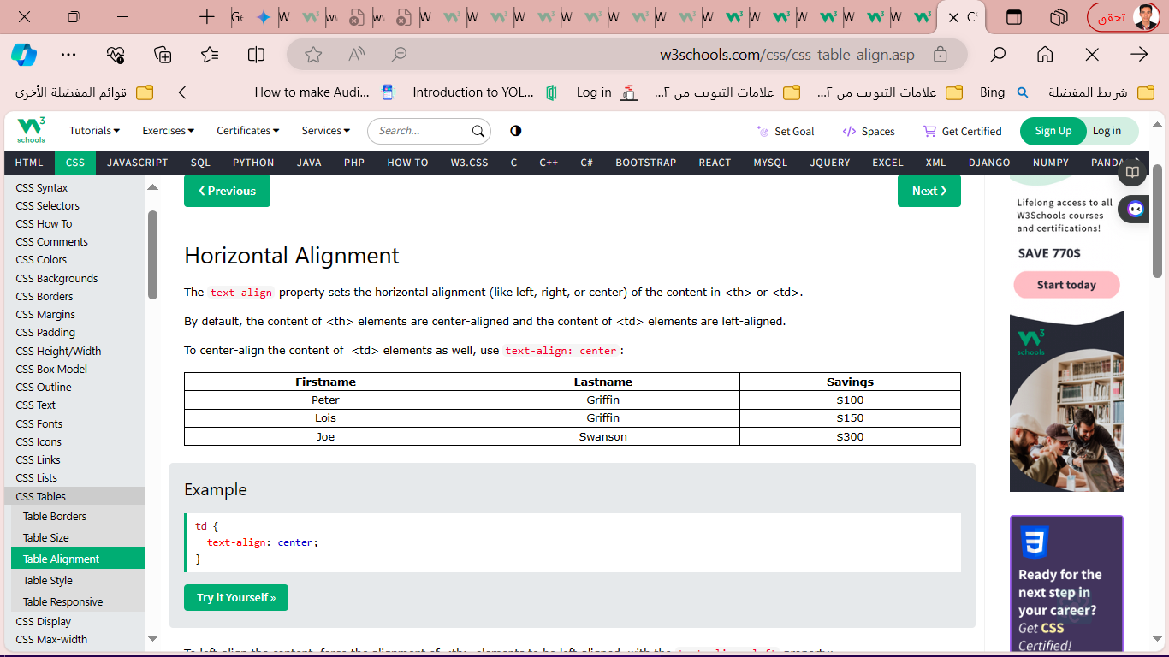

* **Vertical Alignment**

td {  
  height: 50px;  
  vertical-align: bottom;  
}

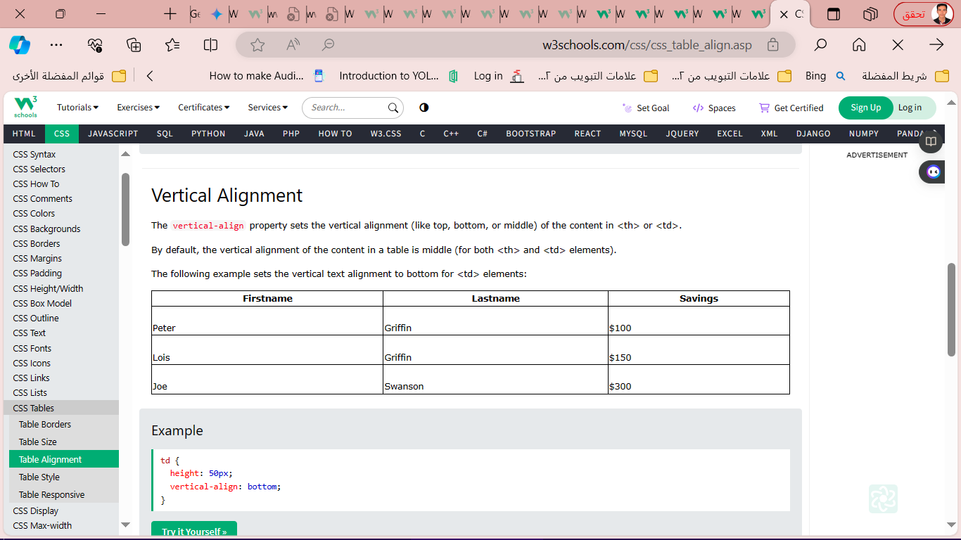

* **CSS Table Style**

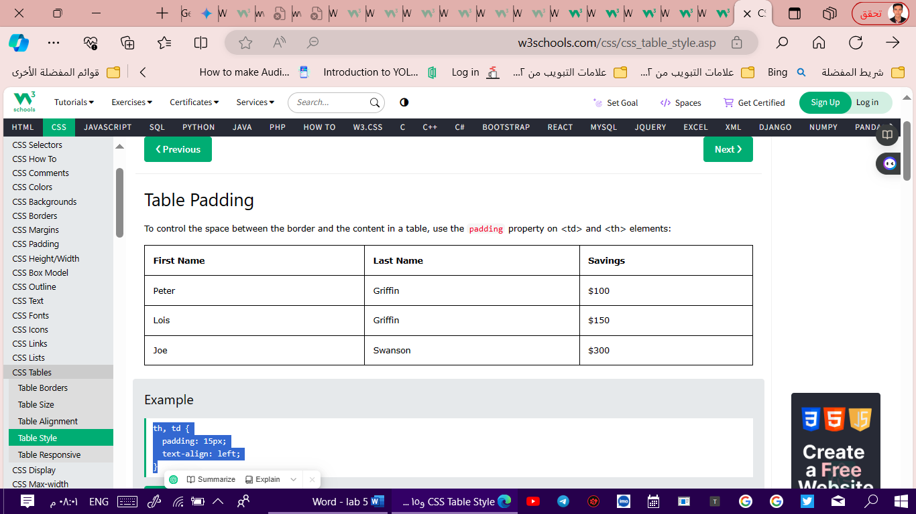**Table Padding**

th, td {  
  padding: 15px;  
  text-align: left;  
}

**Horizontal Dividers**

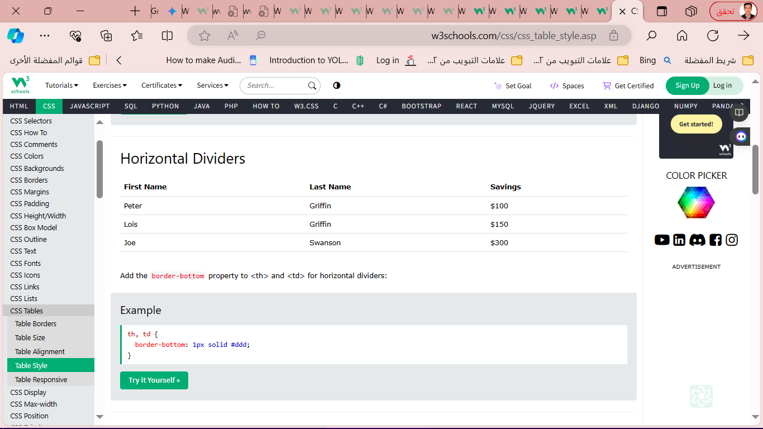Add the border-bottom property to <th> and <td> for horizontal dividers:

th, td {  
  border-bottom: 1px solid #ddd;  
}

* **Hoverable Table**

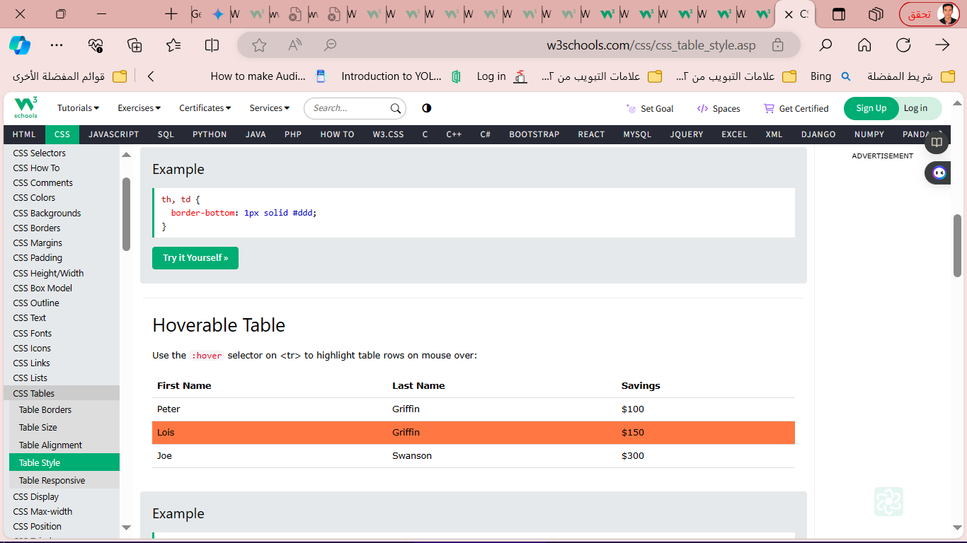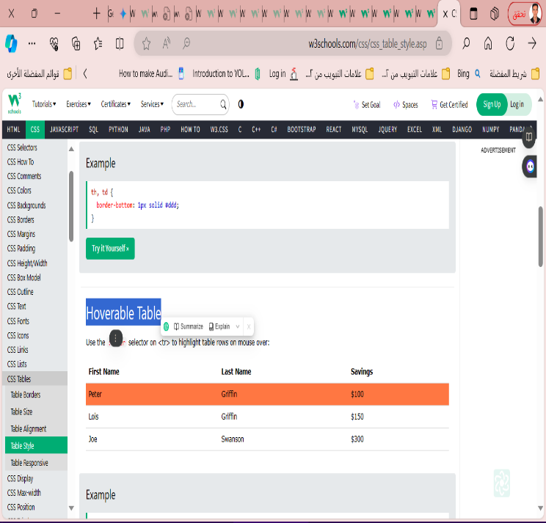Use the :hover selector on <tr> to highlight table rows on mouse over:

**Example**

tr:hover {background-color: coral;}

**Striped Tables**

For zebra-striped tables, use the nth-child() selector and add a background-color to all even (or odd) table rows:

### **Example**

tr:nth-child(even) {background-color: #f2f2f2;}

* **Table Color**

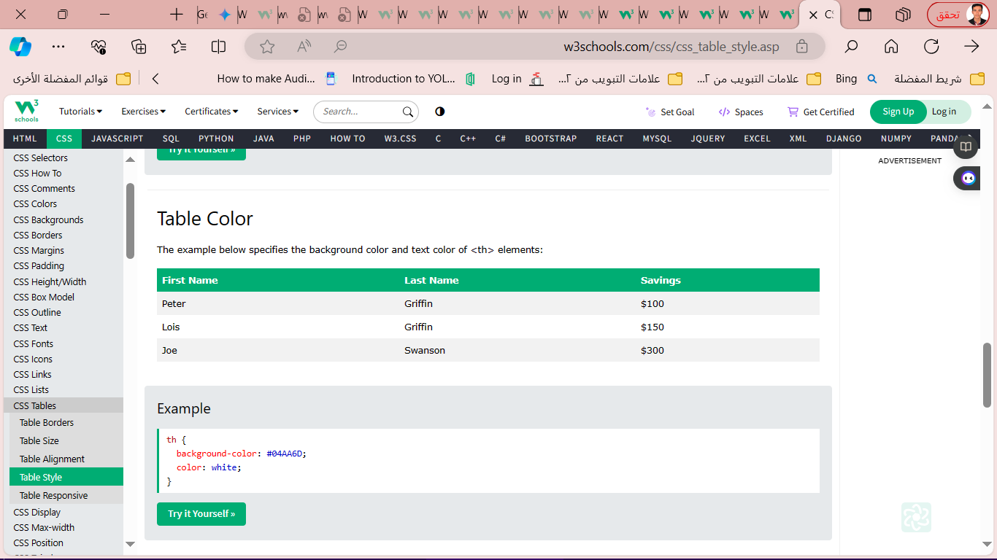The example below specifies the background color and text color of <th> elements:

th {  
  background-color: #04AA6D;  
  color: white;  
}

* **CSS Responsive Table**

A responsive table will display a horizontal scroll bar if the screen is too small to display the full content:

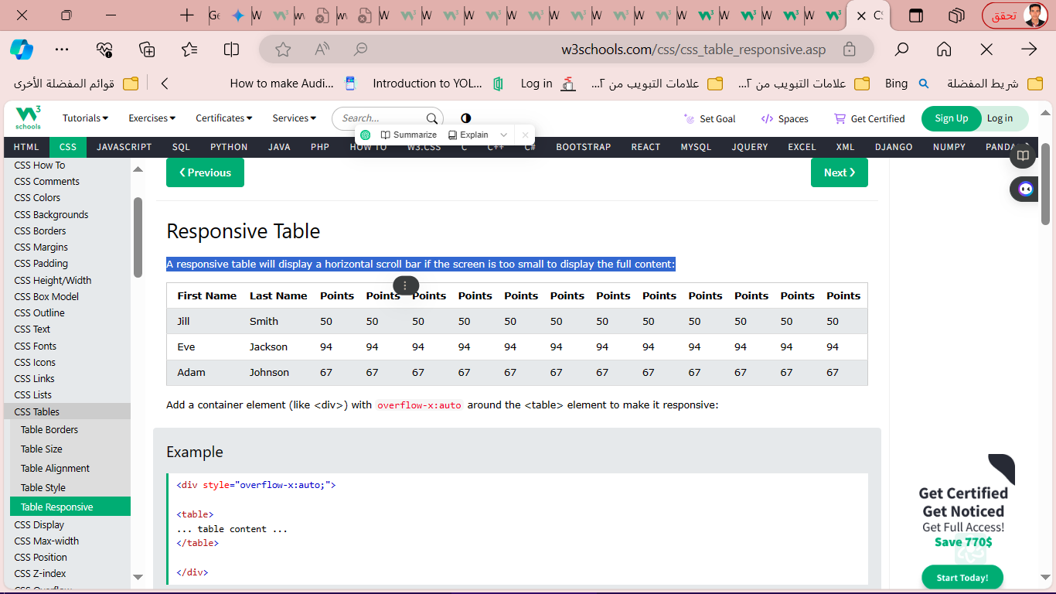

Add a container element (like <div>) with overflow-x:auto around the <table> element to make it responsive:

**Example**

<div style="overflow-x:auto;">  
<table>  
... table content ...  
</table>  
  
</div>

* **CSS Layout – The display Property**

خاصية العرض (display) هي واحدة من أهم خواص CSS التي تتحكم في تخطيط عناصر الصفحة.

تستخدم خاصية العرض لتغيير سلوك العرض الافتراضي لعناصر HTML.

**The display Property**

The display property is used to specify how an element is shown on a web page.

تحدد خاصية العرض (display) كيفية عرض عنصر HTML على صفحة الويب. لكل عنصر HTML قيمة عرض افتراضية تعتمد على نوع العنصر. على سبيل المثال، تكون قيمة العرض الافتراضية لمعظم العناصر إما "block" (مستوى كتلة) أو "inline"مستوى خط.

The display property is used to change the default display behavior of HTML elements.

* **lock-level Elements**

A block-level element ALWAYS starts on a new line and takes up the full width available (stretches out to the left and right as far as it can).

The <div> element is a block-level element.

Examples of block-level elements:

* <div>
* <h1> - <h6>
* <p>
* <form>
* <header>
* <footer>
* <section>
* **Inline Elements**

An inline element DOES NOT start on a new line and only takes up as much width as necessary.

This is an inline <span> element inside a paragraph.

Examples of inline elements:

* <span>
* <a>
* <img>
* **CSS Layout - width and max-width**

sing width, max-width and margin: auto;

As mentioned in the previous chapter; a block-level element always takes up the full width available (stretches out to the left and right as far as it can).

Setting the width of a block-level element will prevent it from stretching out to the edges of its container. Then, you can set the margins to auto, to horizontally center the element within its container. The element will take up the specified width, and the remaining space will be split equally between the two margins:

This <div> element has a width of 500px, and margin set to auto.

**Note:** The problem with the <div> above occurs when the browser window is smaller than the width of the element. The browser then adds a horizontal scrollbar to the page.

Using max-width instead, in this situation, will improve the browser's handling of small windows. This is important when making a site usable on small devices:

This <div> element has a max-width of 500px, and margin set to auto.

**Tip:** Resize the browser window to less than 500px wide, to see the difference between the two divs!

Here is an example of the two divs above:

**Example**

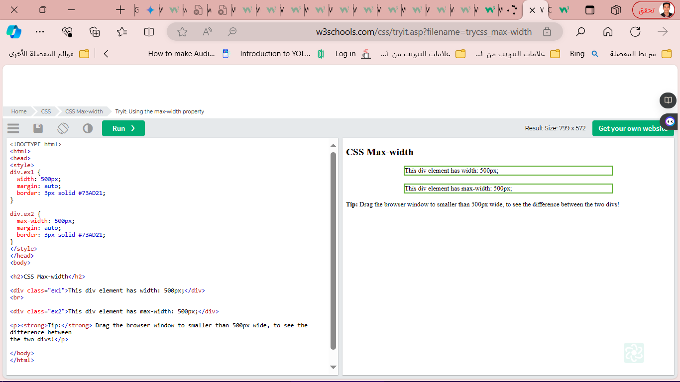div.ex1 {  
  width: 500px;  
  margin: auto;  
  border: 3px solid #73AD21;  
}  
  
div.ex2 {  
  max-width: 500px;  
  margin: auto;  
  border: 3px solid #73AD21;  
}

* **CSS Layout - The position Property**

The position property specifies the type of positioning method used for an element (static, relative, fixed, absolute or sticky).

The position property specifies the type of positioning method used for an element.

There are five different position values:

* static
* relative
* fixed
* absolute
* sticky

Elements are then positioned using the top, bottom, left, and right properties. However, these properties will not work unless the position property is set first. They also work differently depending on the position value.

div.static {  
  position: static;  
  border: 3px solid #73AD21;  
}

* **position: sticky;**

An element with position: sticky; is positioned based on the user's scroll position.

A sticky element toggles between relative and fixed, depending on the scroll position. It is positioned relative until a given offset position is met in the viewport - then it "sticks" in place (like position:fixed).

In this example, the sticky element sticks to the top of the page (top: 0), when you reach its scroll position.

**Example**

div.sticky {  
  position: -webkit-sticky; /* Safari */  
  position: sticky;  
  top: 0;  
  background-color: green;  
  border: 2px solid #4CAF50;}

* **Positioning Text In an Image**

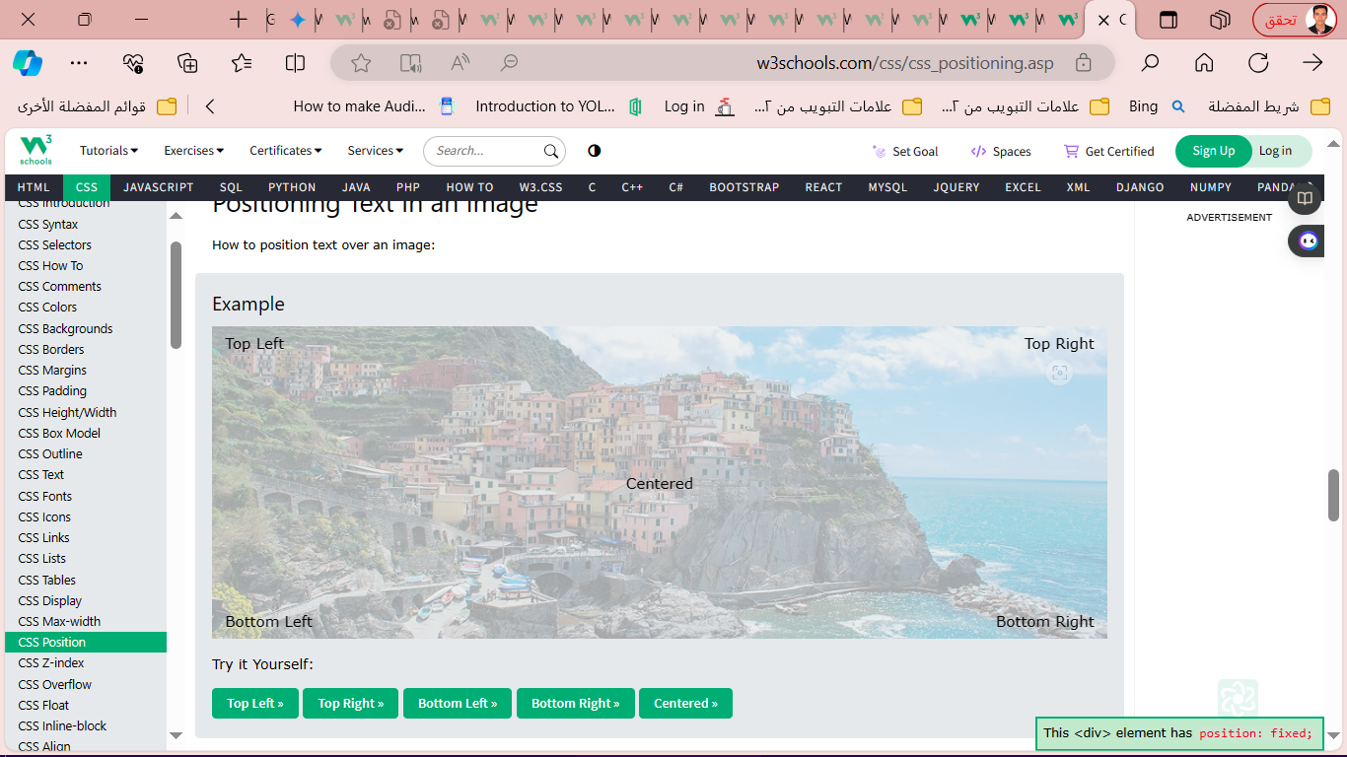

<style>

.container {

position: relative;

}

.topleft {

position: absolute;

top: 8px;

left: 16px;

font-size: 18px;

}

img {

width: 100%;

height: auto;

opacity: 0.3;

}

</style>

</head>

<body>

<h2>Image Text</h2>

<p>Add some text to an image in the top left corner:</p>qe

<div class="container">

<img src="img_5terre_wide.jpg" alt="Cinque Terre" width="1000" height="300">

<div class="topleft">Top Left</div>

</div>

</body>

</html>

* **CSS Layout - float and clear**

**The float Property**

The float property is used for positioning and formatting content e.g. let an image float left to the text in a container.

The float property can have one of the following values:

* left - The element floats to the left of its container
* right - The element floats to the right of its container
* none - The element does not float (will be displayed just where it occurs in the text). This is default
* inherit - The element inherits the float value of its parent

**Example - float: right;**

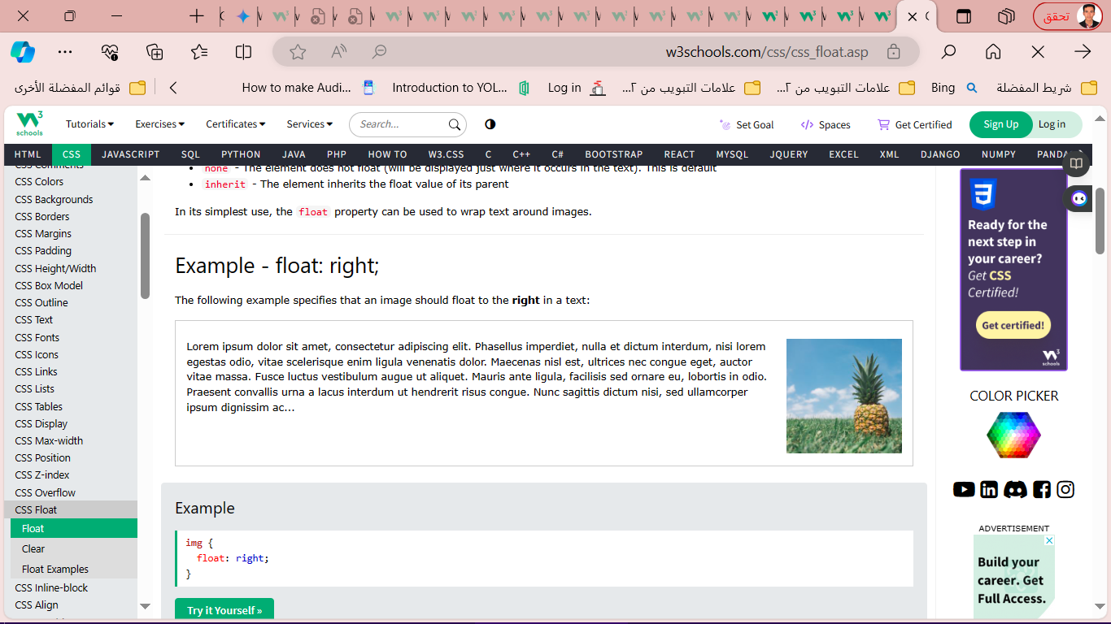

img {  
  float: right;  
}

**Example - Float Next To Each Other**

Example

div {  
  float: left;  
  padding: 15px;  
}  
  
.div1 {  
  background: red;  
}  
  
.div2 {  
  background: yellow;  
}  
  
.div3 {  
  background: green;  
}

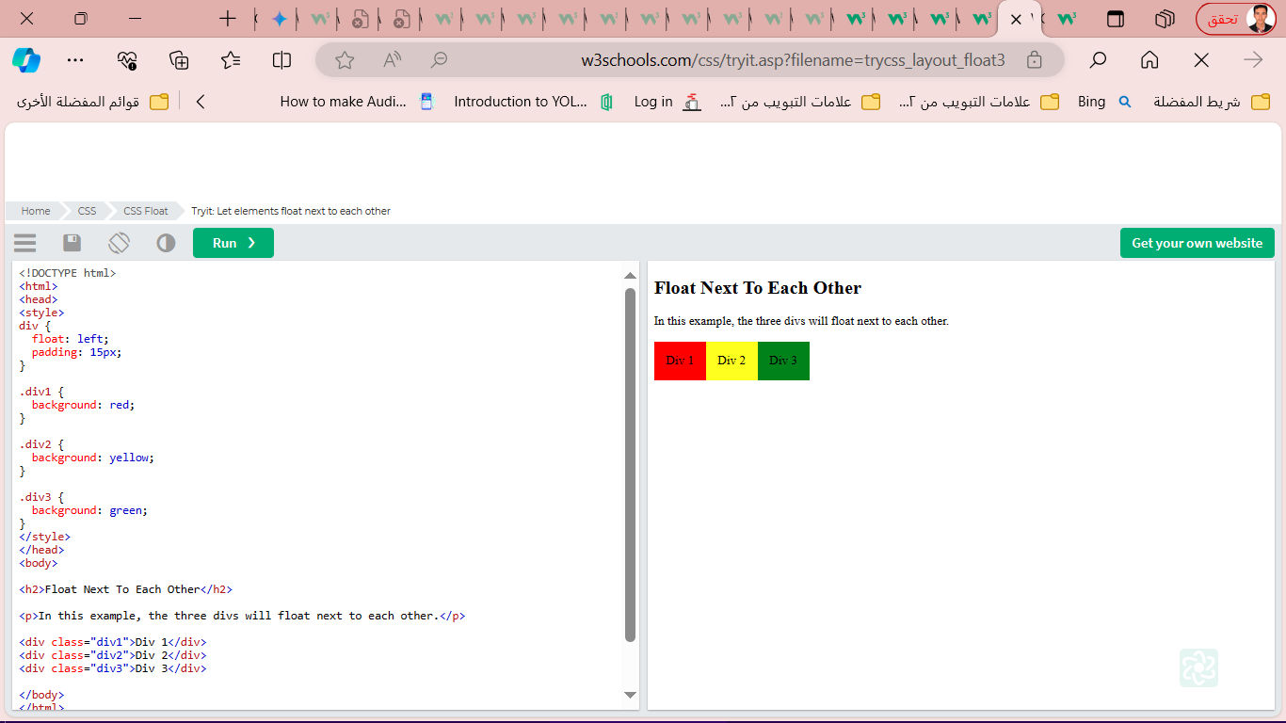

**CSS Layout - clear and clearfix**

**The clear Property**

When we use the float property, and we want the next element below (not on right or left), we will have to use the clear property.

The clear property specifies what should happen with the element that is next to a floating element.

The clear property can have one of the following values:

* none - The element is not pushed below left or right floated elements. This is default
* left - The element is pushed below left floated elements
* right - The element is pushed below right floated elements
* both - The element is pushed below both left and right floated elements
* inherit - The element inherits the clear value from its parent

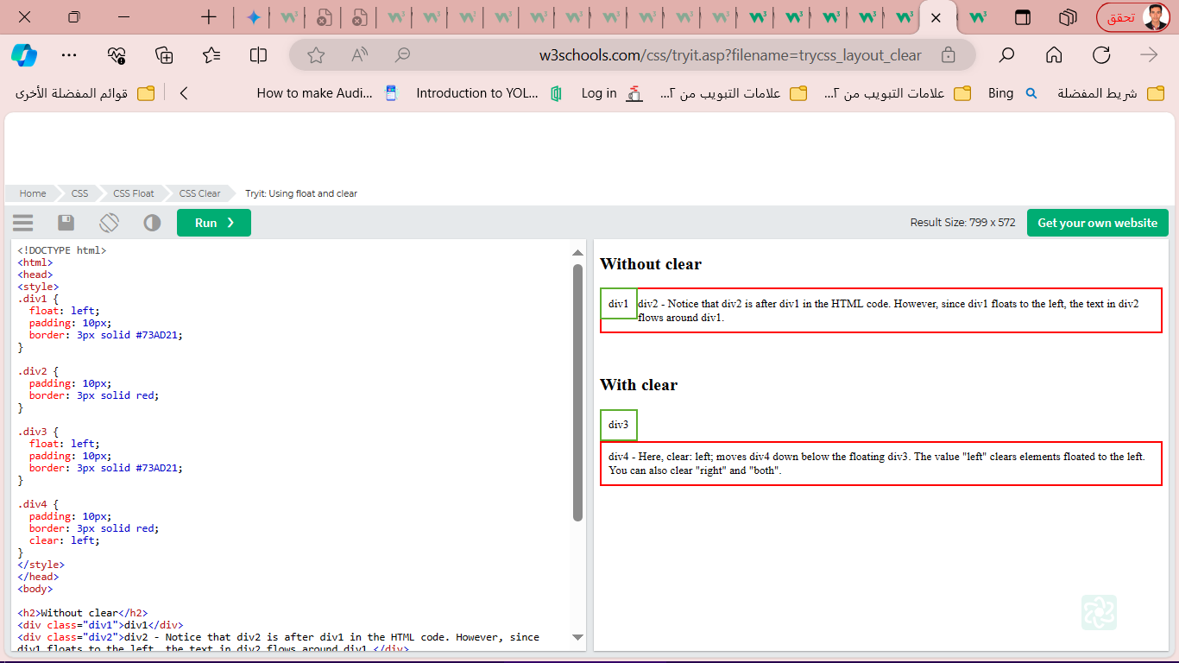div1 {  
  float: left;  
}  
  
div2 {  
  clear: left;  
}

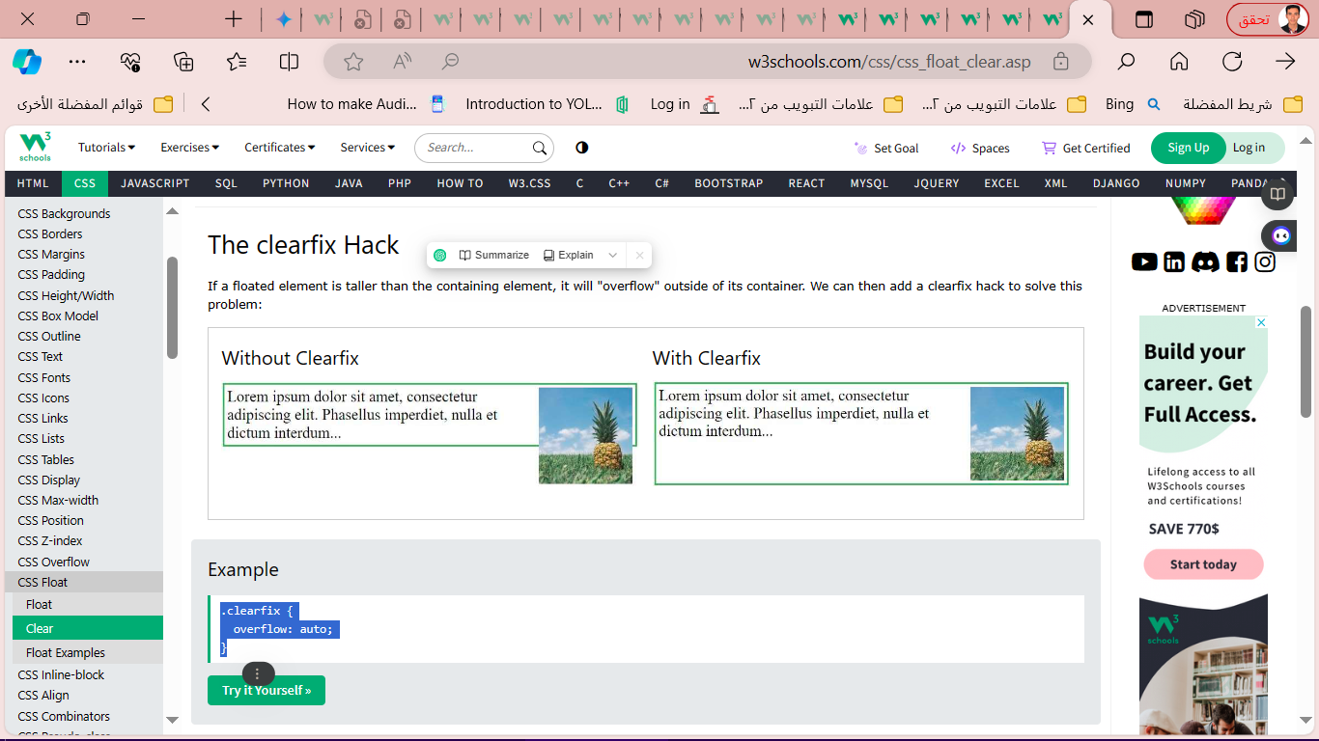**The clearfix Hack**

.clearfix {  
  overflow: auto;  
}

.clearfix::after {  
  content: "";  
  clear: both;  
  display: table;  
}

* 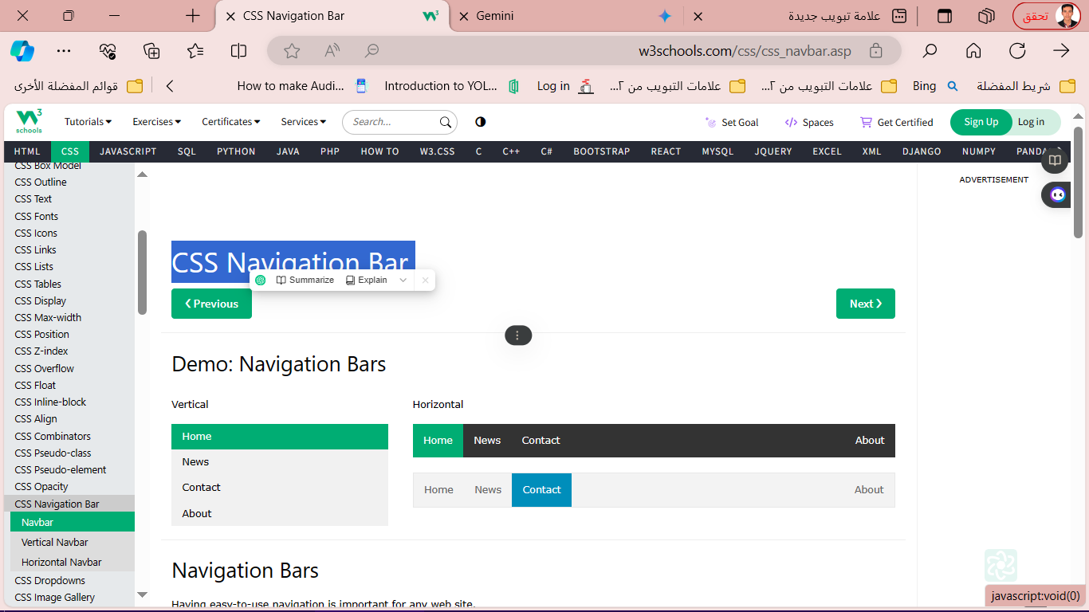**CSS Navigation Bar**

Having easy-to-use navigation is important for any web site.

With CSS you can transform boring HTML menus into good-looking navigation bars.

تعد قوائم التنقل (navigation bars) سهلة الاستخدام عنصرًا مهمًا لأي موقع ويب. فهي تساعد الزوار على الوصول إلى أقسام الموقع المختلفة بسرعة وسهولة.

يمكن أن تكون قوائم التنقل التي يتم إنشاؤها باستخدام HTML فقط ذات مظهر ممل وغير جذابة.

لكن باستخدام لغة تصميم وتنسيق المواقع المت cascading style sheets (CSS) يمكنك تحويل قوائم التنقل البسيطة إلى قوائم تنقل جذابة وواضحة.

* **Navigation Bar = List of Links**

<ul>  
  <li><a href="default.asp">Home</a></li>  
  <li><a href="news.asp">News</a></li>  
  <li><a href="contact.asp">Contact</a></li>  
  <li><a href="about.asp">About</a></li>  
</ul>

remove the bullets and the margins and padding from the list:

ul {  
  list-style-type: none;  
  margin: 0;  
  padding: 0;  
}

* **CSS Vertical Navigation Bar**

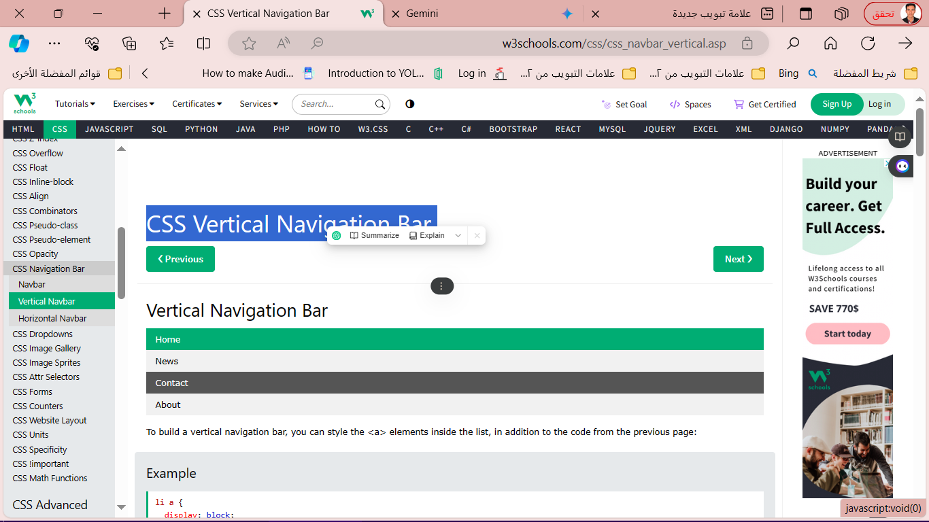

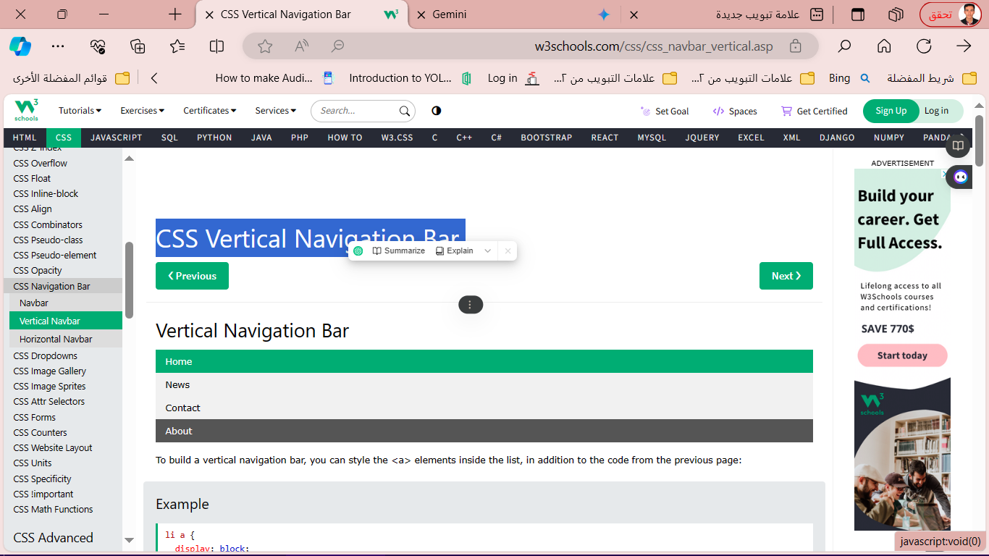

To build a vertical navigation bar, you can style the <a> elements inside the list, in addition to the code from the previous page:

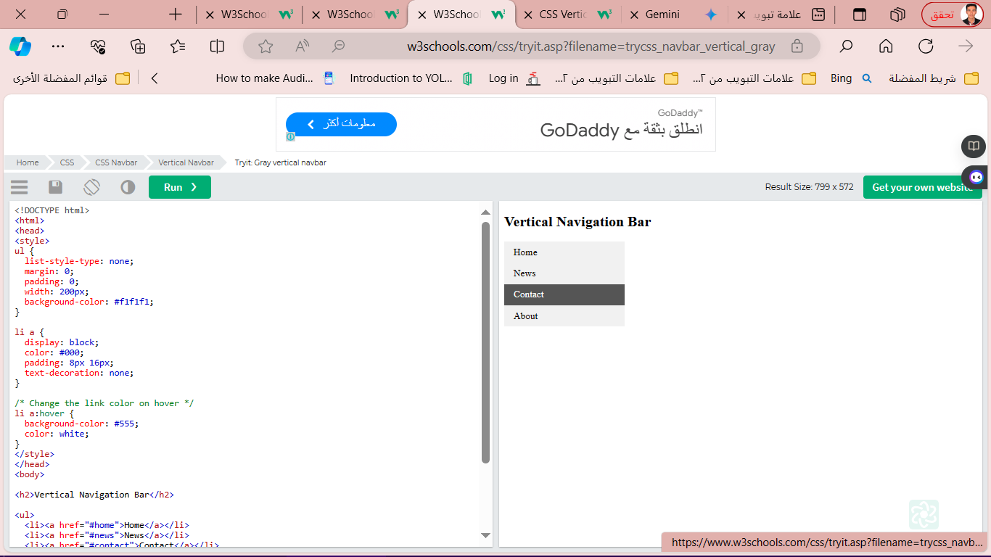li a {  
  display: block;  
  width: 60px;  
}

<ul>

<li><a href="#home">Home</a></li>

<li><a href="#news">News</a></li>

<li><a href="#contact">Contact</a></li>

<li><a href="#about">About</a></li>

</ul>

Example:

ul {  
  list-style-type: none;  
  margin: 0;  
  padding: 0;  
  width: 200px;  
  background-color: #f1f1f1;  
}  
  
li a {  
  display: block;  
  color: #000;  
  padding: 8px 16px;  
  text-decoration: none;  
}  
  
/* Change the link color on hover */  
li a:hover {  
  background-color: #555;  
  color: white;  
}

<h2>Vertical Navigation Bar</h2>

<ul>

<li><a href="#home">Home</a></li>

<li><a href="#news">News</a></li>

<li><a href="#contact">Contact</a></li>

<li><a href="#about">About</a></li>

</ul>

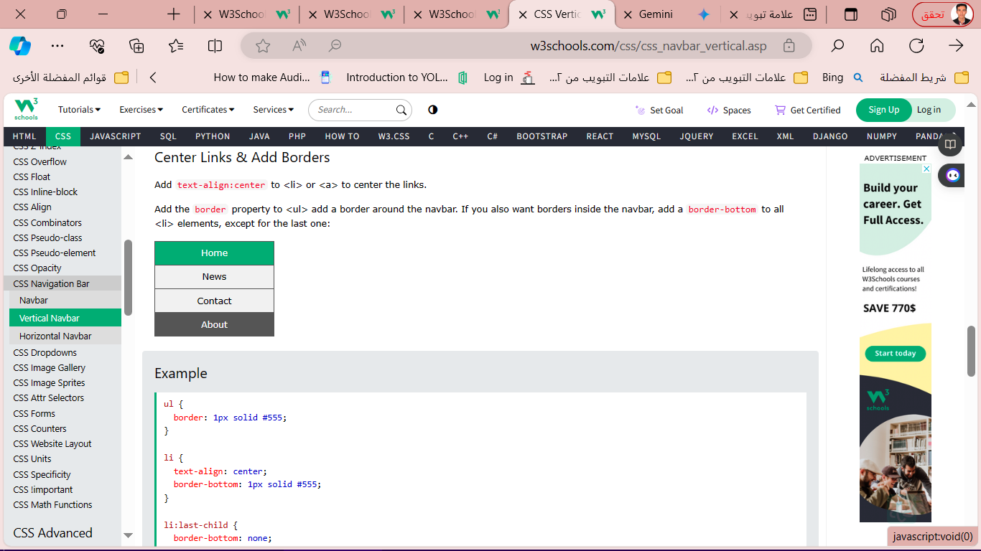

Example :

ul {  
  border: 1px solid #555;  
}  
  
li {  
  text-align: center;  
  border-bottom: 1px solid #555;  
}  
  
li:last-child {  
  border-bottom: none;  
}

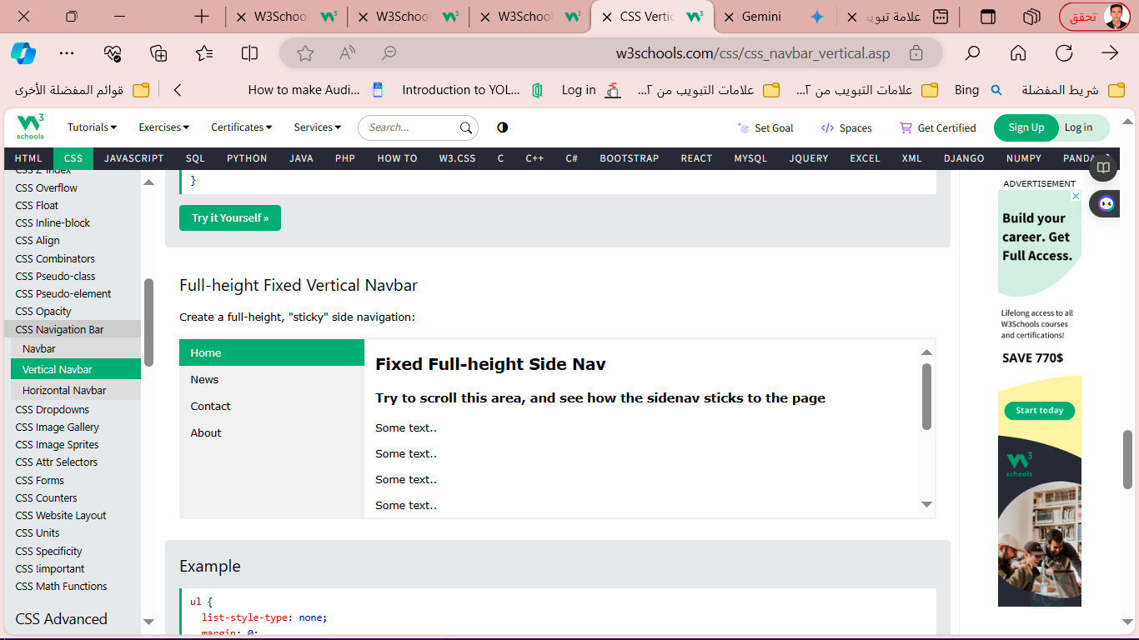  
ul {  
  list-style-type: none;  
  margin: 0;  
  padding: 0;  
  width: 25%;  
  background-color: #f1f1f1;  
  height: 100%; /* Full height */  
  position: fixed; /* Make it stick, even on scroll */  
  overflow: auto; /* Enable scrolling if the sidenav has too much content */  
}

**CSS Horizontal Navigation Bar**

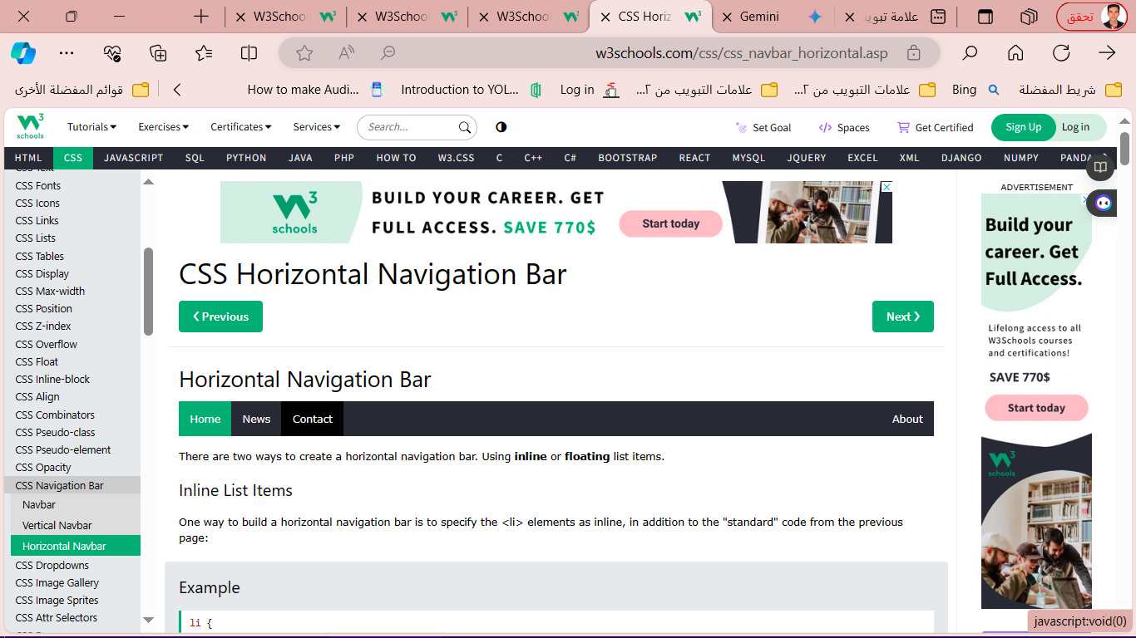

* **Inline List Items**

**Example**

li {  
  display: inline;  
}

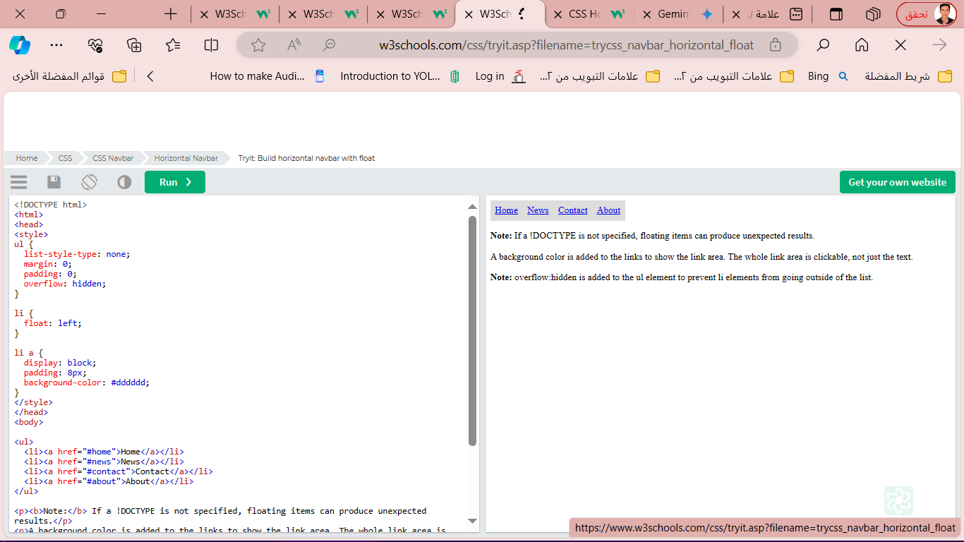------------------------

**list-style-type: none;**

**margin: 0;**

**padding: 0;**

**overflow: hidden;**

**}**

**li {**

**float: left;**

**}**

**li a {**

**display: block;**

**padding: 8px;**

**background-color: #dddddd;**

**}**

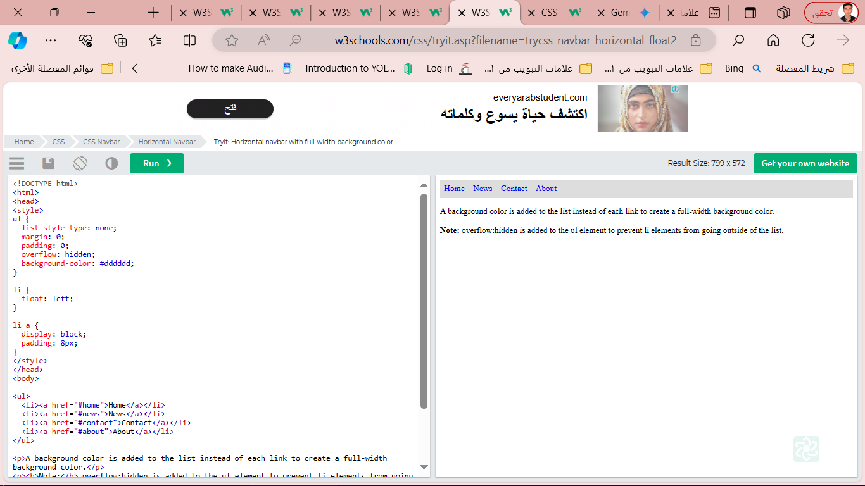ul {

list-style-type: none;

margin: 0;

padding: 0;

overflow: hidden;

background-color: #dddddd;

}

li {

float: left;

}

li a {

display: block;

padding: 8px;

}

**Horizontal Navigation Bar Examples**

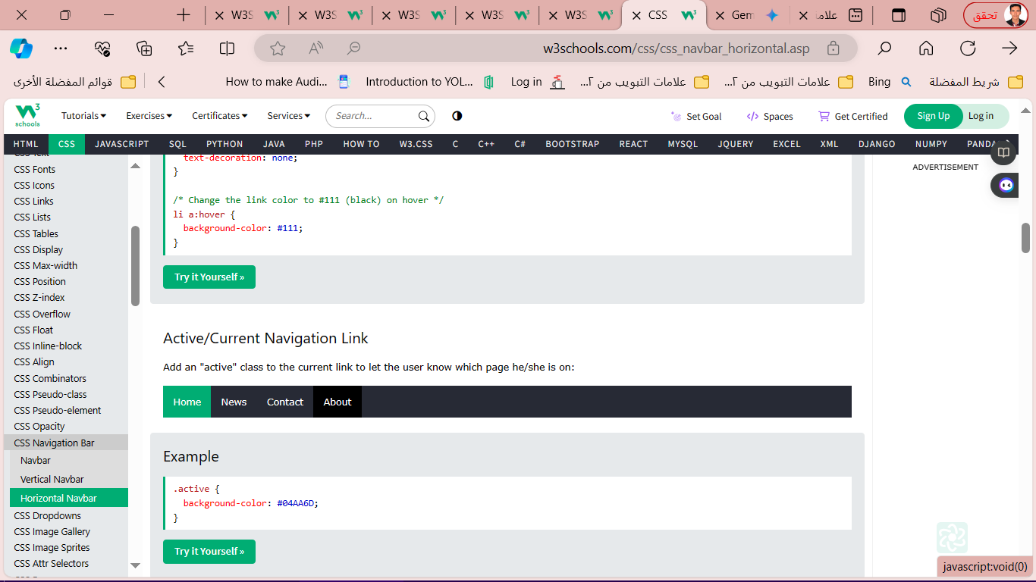

ul {

list-style-type: none;

margin: 0;

padding: 0;

overflow: hidden;

background-color: #333;

}

li {

float: left;

}

li a {

display: block;

color: white;

text-align: center;

padding: 14px 16px;

text-decoration: none;

}

li a:hover:not(.active) {

background-color: #111;

}

.active {

background-color: #04AA6D;

}

**Right-Align Links**

<ul>  
  <li><a href="#home">Home</a></li>  
  <li><a href="#news">News</a></li>  
  <li><a href="#contact">Contact</a></li>  
  <li style="float:right"><a class="active" href="#about">About</a></li>  
</ul>

ul {

list-style-type: none;

margin: 0;

padding: 0;

overflow: hidden;

background-color: #333;

}

li {

float: left;

}

li a {

display: block;

color: white;

text-align: center;

padding: 14px 16px;

text-decoration: none;

}

li a:hover:not(.active) {

background-color: #111;

}

.active {

background-color: #04AA6D;

}

### **Fixed Navigation Bar**

### **Fixed Top**

ul {  
  position: fixed;  
  top: 0;  
  width: 100%;  
}

### **Fixed Bottom**

ul {  
  position: fixed;  
  bottom: 0;  
  width: 100%;  
}

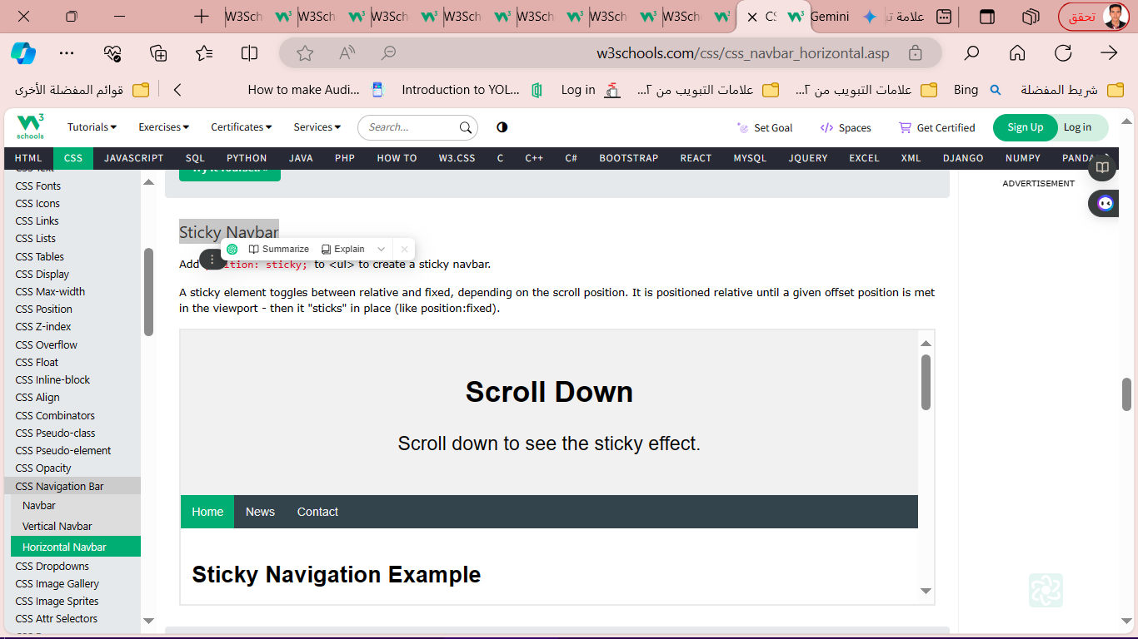**Sticky Navbar**

ul {  
  position: -webkit-sticky; /* Safari */  
  position: sticky;  
  top: 0;  
}

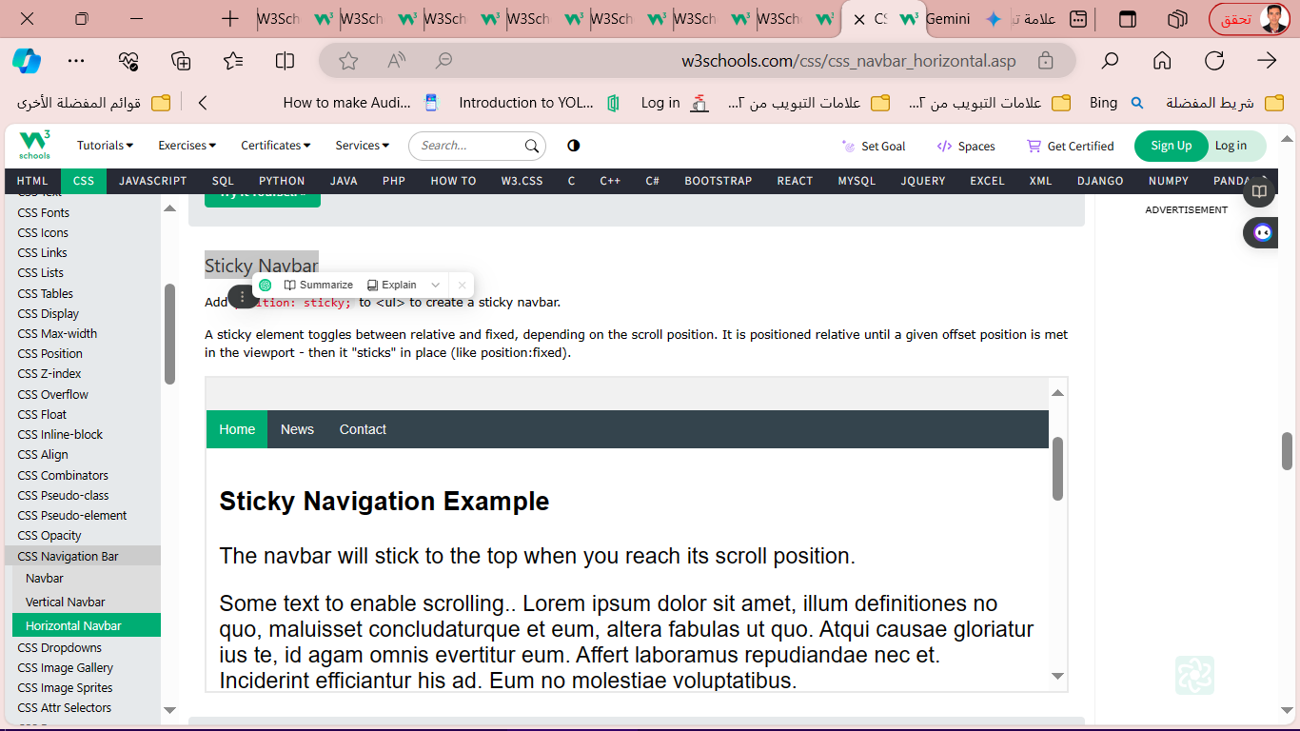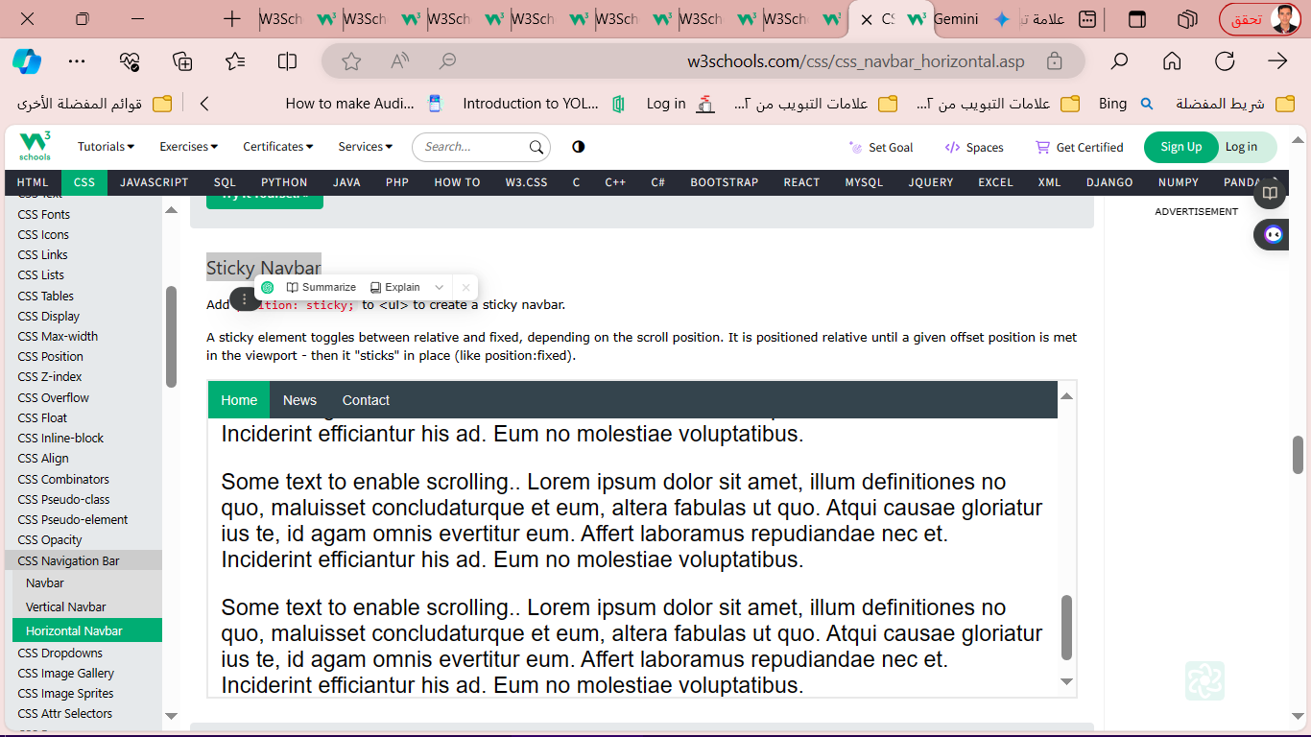

ul {  
  position: -webkit-sticky; /* Safari */  
  position: sticky;  
  top: 0;  
}

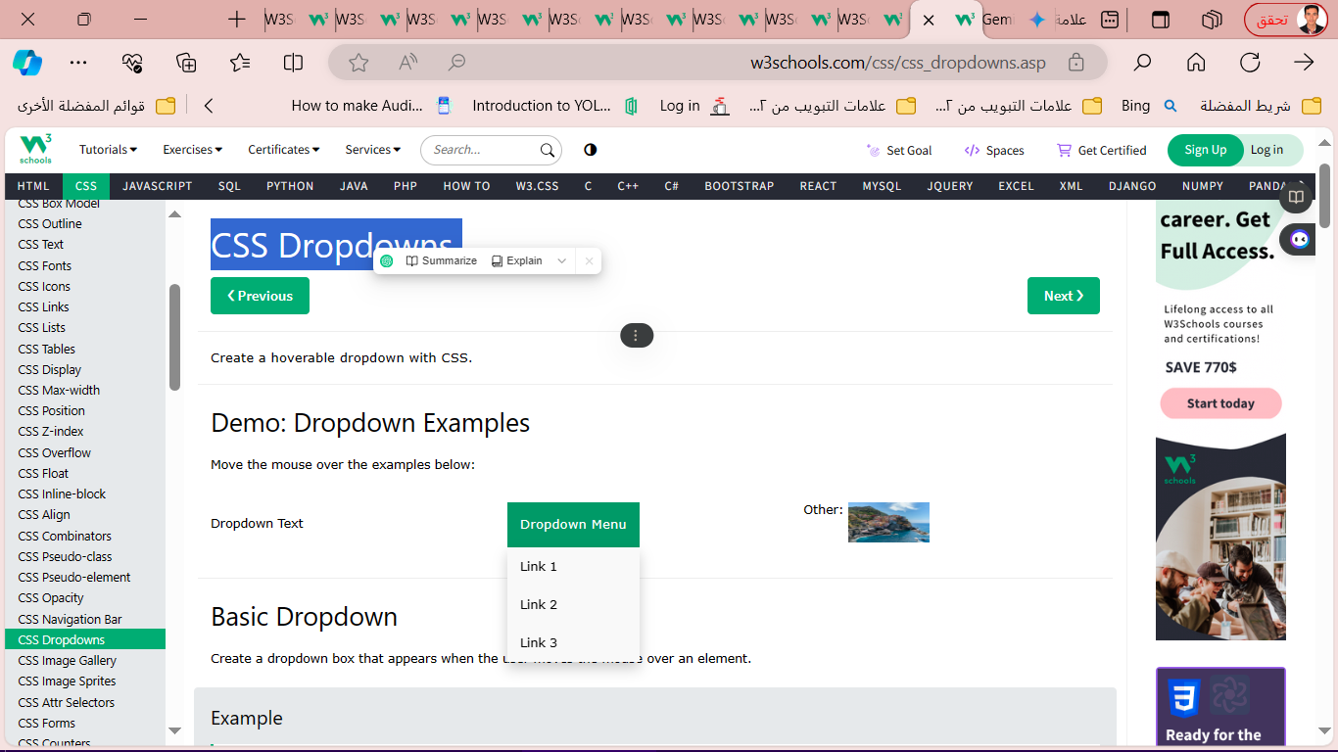

**CSS Dropdowns**

<style>  
.dropdown {  
  position: relative;  
  display: inline-block;  
}  
  
.dropdown-content {  
  display: none;  
  position: absolute;  
  background-color: #f9f9f9;  
  min-width: 160px;  
  box-shadow: 0px 8px 16px 0px rgba(0,0,0,0.2);  
  padding: 12px 16px;  
  z-index: 1;  
}  
  
.dropdown:hover .dropdown-content {  
  display: block;  
}  
</style>  
  
<div class="dropdown">  
  <span>Mouse over me</span>  
  <div class="dropdown-content">  
    <p>Hello World!</p>  
  </div>  
</div>

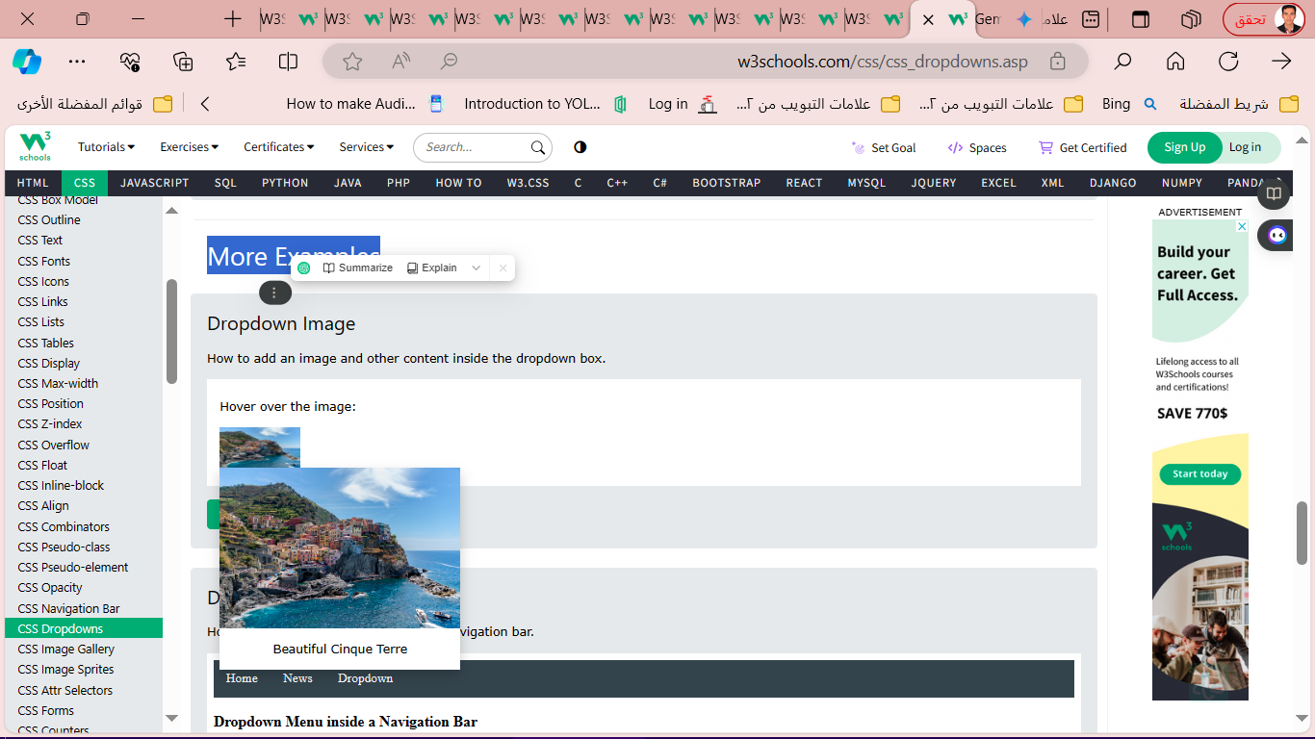

**More Examples**

.dropdown {

position: relative;

display: inline-block;

}

.dropdown-content {

display: none;

position: absolute;

background-color: #f9f9f9;

min-width: 160px;

box-shadow: 0px 8px 16px 0px rgba(0,0,0,0.2);

z-index: 1;

}

.dropdown:hover .dropdown-content {

display: block;

}

.desc {

padding: 15px;

text-align: center;

}

**Dropdown Navbar**

ul {

list-style-type: none;

margin: 0;

padding: 0;

overflow: hidden;

background-color: #333;

}

li {

float: left;

}

li a, .dropbtn {

display: inline-block;

color: white;

text-align: center;

padding: 14px 16px;

text-decoration: none;

}

li a:hover, .dropdown:hover .dropbtn {

background-color: red;

}

li.dropdown {

display: inline-block;

}

.dropdown-content {

display: none;

position: absolute;

background-color: #f9f9f9;

min-width: 160px;

box-shadow: 0px 8px 16px 0px rgba(0,0,0,0.2);

z-index: 1;

}

.dropdown-content a {

color: black;

padding: 12px 16px;

text-decoration: none;

display: block;

text-align: left;

}

.dropdown-content a:hover {background-color: #f1f1f1;}

.dropdown:hover .dropdown-content {

display: block;

}

</style>

</head>

<body>

<ul>

<li><a href="#home">Home</a></li>

<li><a href="#news">News</a></li>

<li class="dropdown">

<a href="javascript:void(0)" class="dropbtn">Dropdown</a>

<div class="dropdown-content">

<a href="#">Link 1</a>

<a href="#">Link 2</a>

<a href="#">Link 3</a>

</div>

</li>

</ul>

<h3>Dropdown Menu inside a Navigation Bar</h3>

<p>Hover over the "Dropdown" link to see the dropdown menu.</p>

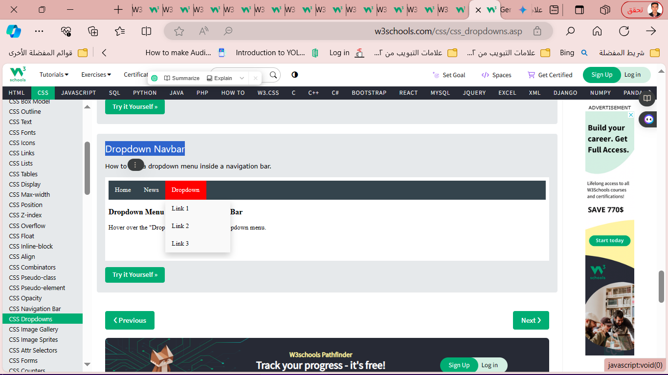

* 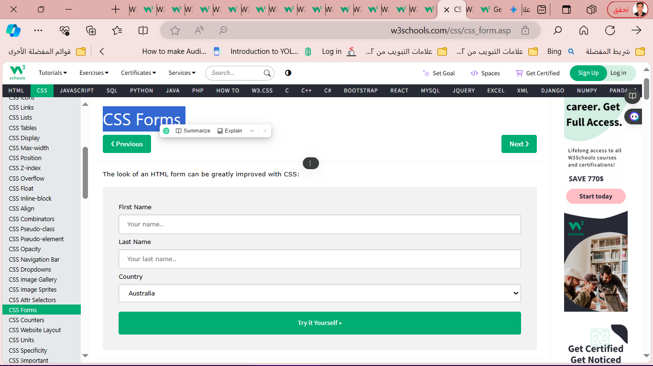**CSS Forms**

**Styling Input Fields**

Use the width property to determine the width of the input field:

**Padded Inputs**

Use the padding property to add space inside the text field.

input[type=text] {  
  width: 100%;  
  padding: 12px 20px;  
  margin: 8px 0;  
  box-sizing: border-box;  
}

**Bordered Inputs**

input[type=text] {  
  border: 2px solid red;  
  border-radius: 4px;  
}

input[type=text] {  
  border: none;  
  border-bottom: 2px solid red;  
}

**Colored Inputs**

input[type=text] {  
  background-color: #3CBC8D;  
  color: white;  
}

**Focused Inputs**

input[type=text]:focus {  
  background-color: lightblue;  
}

input[type=text]:focus {  
  border: 3px solid #555;  
}

**Input with icon/image**

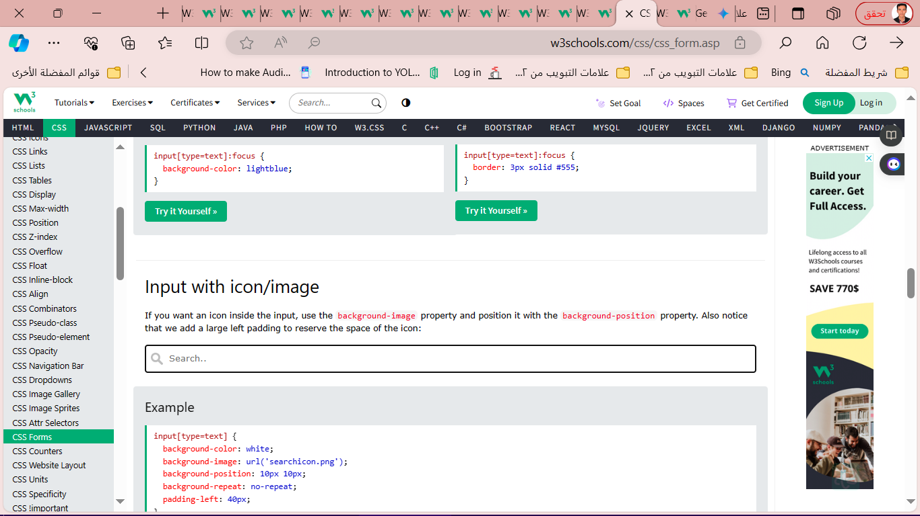

input[type=text] {  
  background-color: white;  
  background-image: url('searchicon.png');  
  background-position: 10px 10px;  
  background-repeat: no-repeat;  
  padding-left: 40px;  
}

**Animated Search Input**

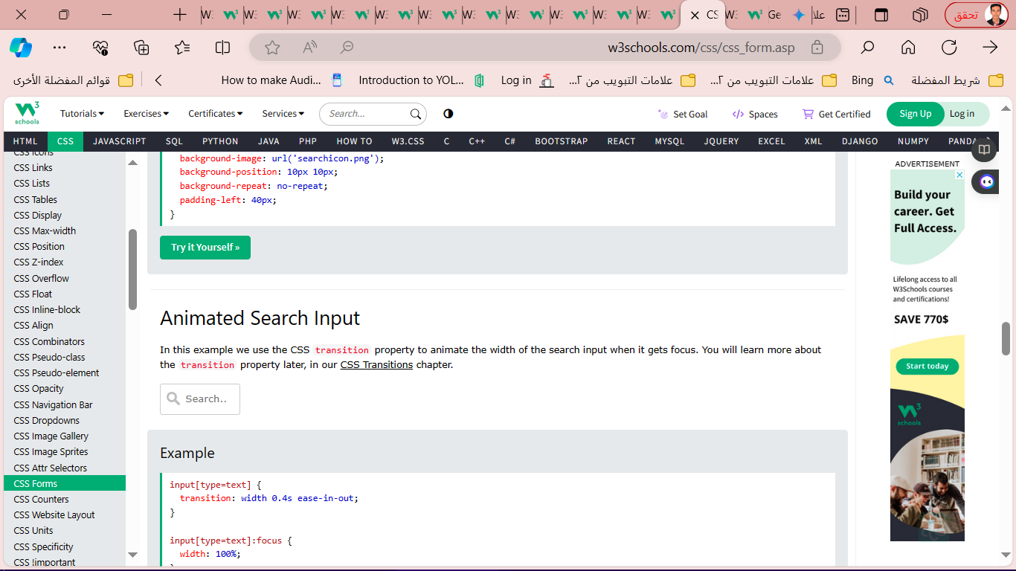

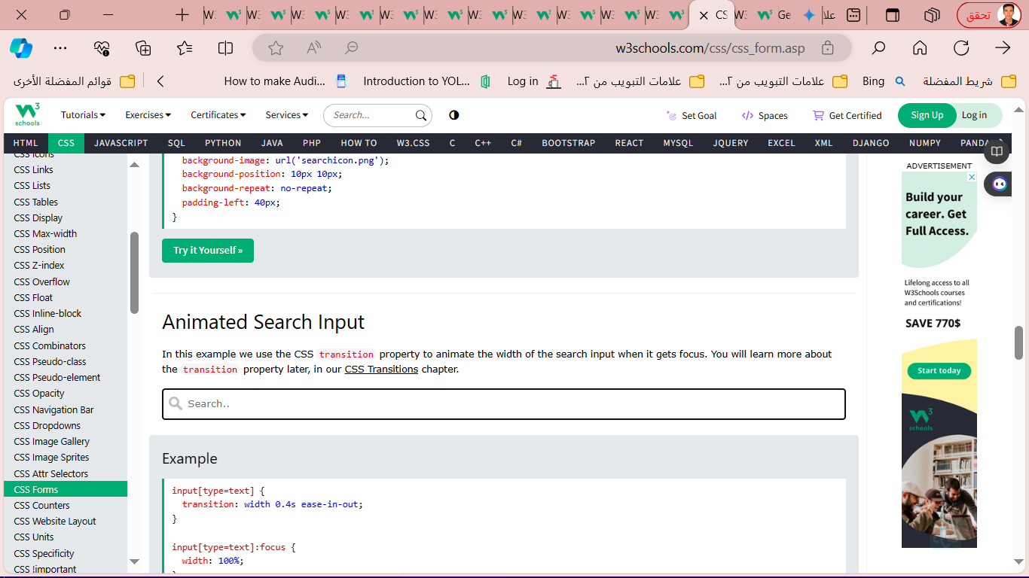

input[type=text] {  
  transition: width 0.4s ease-in-out;  
}  
  
input[type=text]:focus {  
  width: 100%;  
}